BIRTHDAY CAKE

Suggested year group | Year 10/11 Intermediate
Suggested time scale | 1 hour
Learning objectives | Applying knowledge of volume, circle area and circumference in a practical context.
Learning outcomes | Learners will be able to identify relevant methods and correctly apply them in context.
Prior knowledge | - Volume of a cuboid  - Area of a circle  - Volume of a cylinder  - Circumference of a circle  - Metric units of measurement

PPT Slide | Teacher Activity | Learner Activity
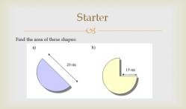  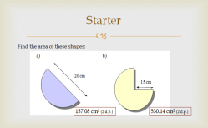 | Show starter problem.  Show solutions and ask learners to explain their methods. | Learners find the area of the shapes then discuss their methods.  10 minutes
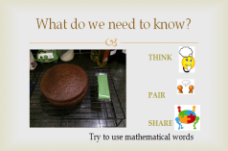  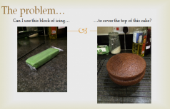 | Introduce the problem.  Encourage pupils to use mathematical terms in their discussions.  Facilitate whole class discussion of applicable methods and measurements needed. | Learners brainstorm ideas for tackling the problem and what methods could be used.  List what information is needed (Think, Pair, Share).  5 minutes
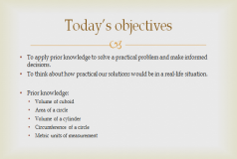 | Ask learners to suggest what today’s objectives will be and what prior knowledge will be needed.  Share learning objectives and recap methods needed.  [Or you may wish to conceal the prior knowledge topics at this stage so that pupils identify the methods independently.] | Learners are to think independently about what this lesson’s objectives are and what prior knowledge will be used.  5 minutes
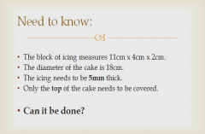 | Share the necessary measurements with pupils. You may choose to withhold some of the information until they ask for it, then provide it either on the board or printed on cards.  [It is important that they know that the icing needs to be 5mm thick, as this is what turns it into a volume problem.] | In pairs, learners attempt to calculate whether the block of icing can fully cover the top of the cake.  10-15 minutes
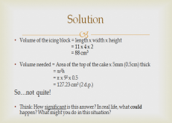  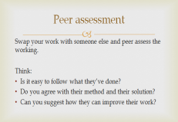  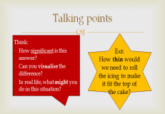 | Ask pupils to peer assess each other’s methods.  Discuss methods and share solution for comparing the volume of icing available with the volume required.  Ask learners to comment on the significance of this solution, estimating the size of the area that won’t be covered, and what could be done to compensate for the fact that the icing won’t completely cover the top.  Their suggestions may lead to further calculations. | Compare methods and solutions with other pairs, assessing the quality of their communication.  Suggest practical solutions for the problem that the icing won’t cover the top of the cake.  [They may suggest, e.g. rolling the icing out thinner. This could lead to an extension question: How thin would the icing need to be to make it cover the top?. Then you may ask them to estimate How thin is too thin?, thinking in practical terms, as we still need to be able to work with the icing, and we want the cake to taste good.]  5-10 minutes
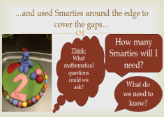  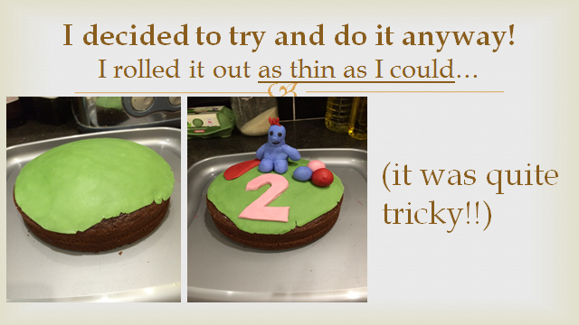 | Present the next part of the problem. First ask pupils to consider what mathematical questions we could ask, then what information we need to work out how many Smarties are needed. | Discuss what information is needed (Think, Pair, Share).  2 minutes
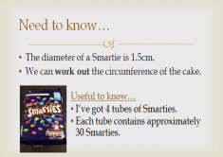 | Share the necessary information (again you may choose to withhold this until learners ask for it.)  The last 2 points are not essential to answering the question but are useful to know, and pupils may raise this anyway. | Calculate the number of Smarties needed to cover the edge of the top of the cake.  5 minutes
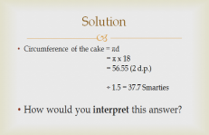 | Discuss the solution and ask pupils to interpret the answer in practical terms, e.g. Are we really going to measure out .7 of a Smartie?! | Comment on the solution in practical terms.  2 minutes
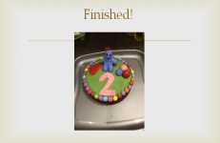 | Revisit objectives. | Discuss to what extent today’s objectives have been met.  2 minutes
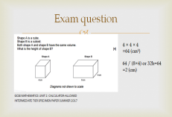  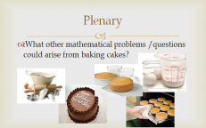 | Plenary: What other mathematical problems / questions could arise from baking a cake?  [Pictures can be shown as stimulus or left out].  Extra: Exam question involving comparison of volume. | Discuss suggestions for plenary.  Attempt exam question.  5 minutes
Resources:
Calculators; Information cards (optional)
I

