Workings and final answer.

What have we learned?

What other mathematical techniques do we need to apply?

What useful information do we know?

**REMEMBER**! Accuracy and spelling of key words * Appropriate paragraphing and sequencing of information presented * Correct phrasing – capitals, punctuation.

What do we want to find out?

Mathematics Unit 9: Robberies

**QUESTION 9.1**  
A TV reporter showed this graph and said: “The graph shows that there is a huge increase in the number of robberies from 1998 to 1999.”  
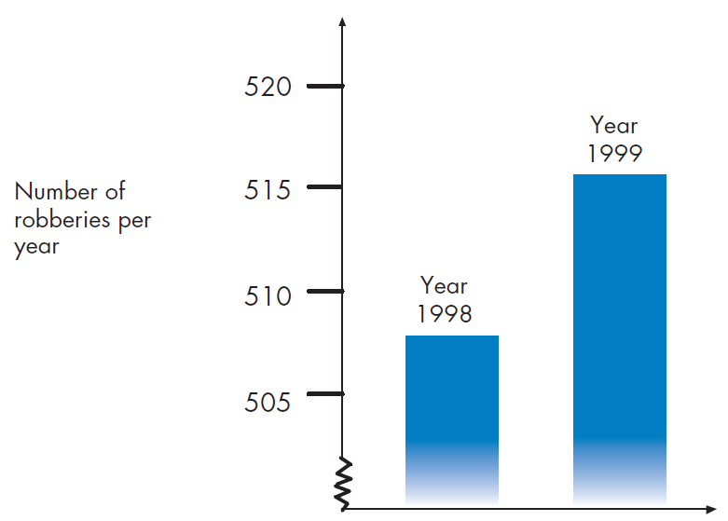  
Do you consider the reporter’s statement to be a reasonable interpretation of the graph? Give and explanation to support your answer.