Workings and final answer.

What have we learned?

What other mathematical techniques do we need to apply?

What useful information do we know?

**REMEMBER**! Accuracy and spelling of key words * Appropriate paragraphing and sequencing of information presented * Correct phrasing – capitals, punctuation.

What do we want to find out?

Mathematics Unit 6: Growing up

**Youth grows taller**In 1998 the average height of both young males and young females in the Netherlands is represented in this graph.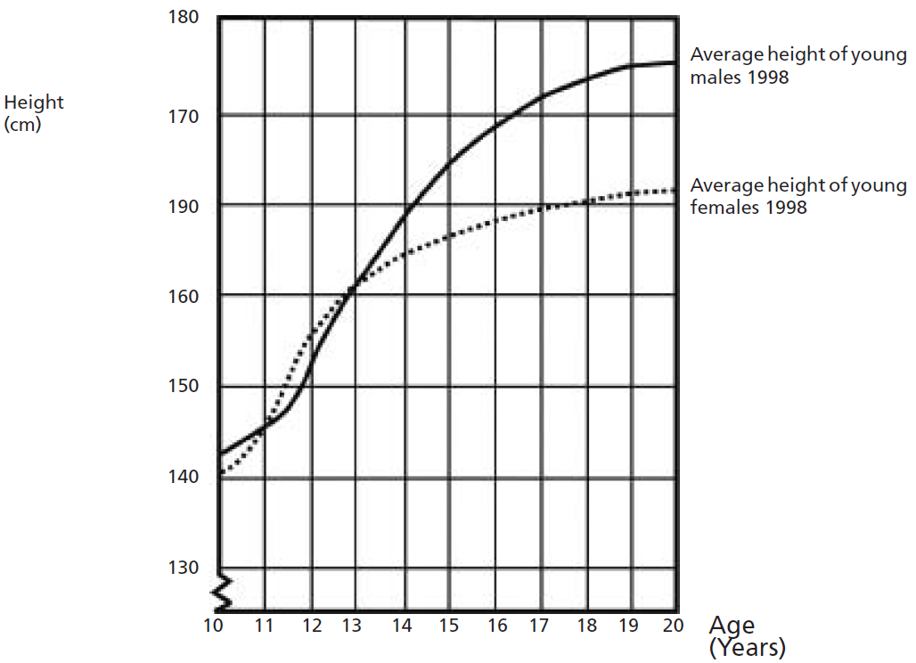  
[Erratum: Correct vertical scale 170-180-190.]  
**QUESTION 6.1**Since 1980 the average height of 20-year-old females has increased by 2.3 cm, to 170.6 cm. What was the average height of a 20-year-old female in 1980?

Workings and final answer.

What have we learned?

What other mathematical techniques do we need to apply?

What useful information do we know?

**REMEMBER**! Accuracy and spelling of key words * Appropriate paragraphing and sequencing of information presented * Correct phrasing – capitals, punctuation.

What do we want to find out?

Mathematics Unit 6: Growing up

**Youth grows taller**In 1998 the average height of both young males and young females in the Netherlands is represented in this graph.  
[Erratum: Correct vertical scale 170-180-190.]  
**QUESTION 6.2**Explain how the graph shows that on average the growth rate for girls slows down after 12 years of age.

**Youth grows taller**In 1998 the average height of both young males and young females in the Netherlands is represented in this graph.   
[Erratum: Correct vertical scale 170-180-190.]  
**QUESTION 6.3**According to this graph, on average, during which period in their life are females taller than males of the same age?

Workings and final answer.

What have we learned?

What other mathematical techniques do we need to apply?

What useful information do we know?

**REMEMBER**! Accuracy and spelling of key words * Appropriate paragraphing and sequencing of information presented * Correct phrasing – capitals, punctuation.

What do we want to find out?

Mathematics Unit 6: Growing up