Workings and final answer.

What have we learned?

What other mathematical techniques do we need to apply?

What useful information do we know?

**REMEMBER**! Accuracy and spelling of key words * Appropriate paragraphing and sequencing of information presented * Correct phrasing – capitals, punctuation.

What do we want to find out?

Mathematics Unit 43: Lighthouse

Lighthouses are towers with a light beacon on top. Lighthouses assist sea ships in finding their way at night when they are sailing close to the shore.

A lighthouse beacon sends out light flashes with a regular fixed pattern. Every lighthouse has its own pattern.

In the diagram below you see the pattern of a certain lighthouse. The light flashes alternate with dark periods.

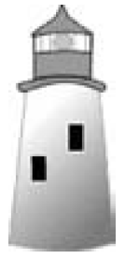 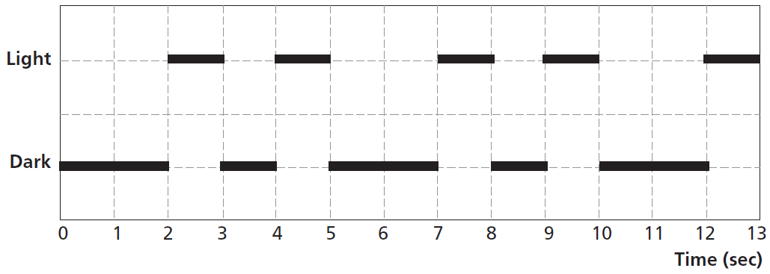

It is a regular pattern. After some time the pattern repeats itself. The time taken by one complete cycle of a pattern, before it starts to repeat, is called the *period*. When you find the period of a pattern, it is easy to extend the diagram for the next seconds or minutes or even hours.

Workings and final answer.

What have we learned?

What other mathematical techniques do we need to apply?

What useful information do we know?

**REMEMBER**! Accuracy and spelling of key words * Appropriate paragraphing and sequencing of information presented * Correct phrasing – capitals, punctuation.

What do we want to find out?

Mathematics Unit 43: Lighthouse

In the diagram below you see the pattern of a certain lighthouse. The light flashes alternate with dark periods.  
  
It is a regular pattern. After some time the pattern repeats itself. The time taken by one complete cycle of a pattern, before it starts to repeat, is called the *period*.

**QUESTION 43.1**  
Which of the following could be the period of the pattern of this lighthouse?

1. 2 seconds.
2. 3 seconds.
3. 5 seconds.
4. 12 seconds.

In the diagram below you see the pattern of a certain lighthouse. The light flashes alternate with dark periods.  
  
It is a regular pattern. After some time the pattern repeats itself. The time taken by one complete cycle of a pattern, before it starts to repeat, is called the *period*.

**QUESTION 43.2**For how many seconds does the lighthouse send out light flashes in 1 minute?

1. 4
2. 12
3. 20
4. 24

Workings and final answer.

What have we learned?

What other mathematical techniques do we need to apply?

What useful information do we know?

**REMEMBER**! Accuracy and spelling of key words * Appropriate paragraphing and sequencing of information presented * Correct phrasing – capitals, punctuation.

What do we want to find out?

Mathematics Unit 7: Speed of Racing Car

Workings and final answer.

What have we learned?

What other mathematical techniques do we need to apply?

What useful information do we know?

**REMEMBER**! Accuracy and spelling of key words * Appropriate paragraphing and sequencing of information presented * Correct phrasing – capitals, punctuation.

What do we want to find out?

Mathematics Unit 43: Lighthouse

Workings and final answer.

What have we learned?

What other mathematical techniques do we need to apply?

What useful information do we know?

**REMEMBER**! Accuracy and spelling of key words * Appropriate paragraphing and sequencing of information presented * Correct phrasing – capitals, punctuation.

What do we want to find out?

Mathematics Unit 43: Lighthouse

In the diagram below you see the pattern of a certain lighthouse. The light flashes alternate with dark periods.  
  
**QUESTION 43.3**  
In the diagram below, make a graph of a possible pattern of light flashes of a lighthouse that sends out light flashes for 30 seconds per minute. The period of this pattern must be equal to 6 seconds.  
