Workings and final answer.

What have we learned?

What other mathematical techniques do we need to apply?

What useful information do we know?

**REMEMBER**! Accuracy and spelling of key words * Appropriate paragraphing and sequencing of information presented * Correct phrasing – capitals, punctuation.

What do we want to find out?

Mathematics Unit 34: Building Blocks

Susan likes to build blocks from small cubes like the one shown in the following diagram:  
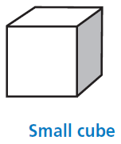  
Susan has lots of small cubes like this one. She uses glue to join cubes together to make other blocks.

First, Susan glues eight of the cubes together to make the block shown in Diagram A below. Then Susan makes the solid blocks shown in Diagram B and Diagram C below.  
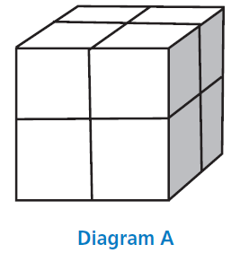 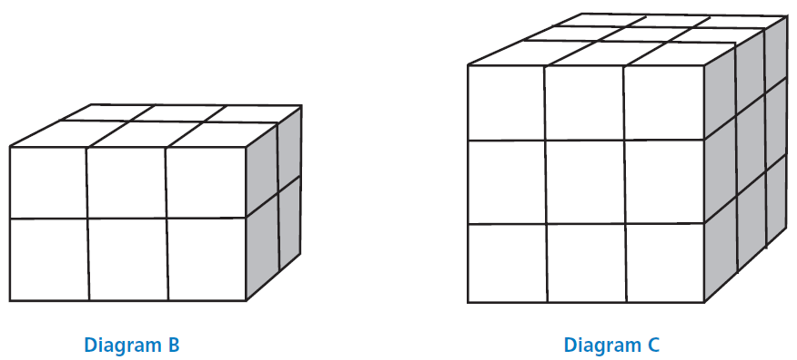

**QUESTION 34.1**How many small cubes will Susan need to make the block shown in Diagram B?

Workings and final answer.

What have we learned?

What other mathematical techniques do we need to apply?

What useful information do we know?

**REMEMBER**! Accuracy and spelling of key words * Appropriate paragraphing and sequencing of information presented * Correct phrasing – capitals, punctuation.

What do we want to find out?

Mathematics Unit 34: Building Blocks

Susan likes to build blocks from small cubes like the one shown in the following diagram:  
  
Susan has lots of small cubes like this one. She uses glue to join cubes together to make other blocks.

First, Susan glues eight of the cubes together to make the block shown in Diagram A below. Then Susan makes the solid blocks shown in Diagram B and Diagram C below.  
 

**QUESTION 34.2**How many small cubes will Susan need to make the block shown in Diagram C?

Workings and final answer.

What have we learned?

What other mathematical techniques do we need to apply?

What useful information do we know?

**REMEMBER**! Accuracy and spelling of key words * Appropriate paragraphing and sequencing of information presented * Correct phrasing – capitals, punctuation.

What do we want to find out?

Mathematics Unit 7: Speed of Racing Car

Workings and final answer.

What have we learned?

What other mathematical techniques do we need to apply?

What useful information do we know?

**REMEMBER**! Accuracy and spelling of key words * Appropriate paragraphing and sequencing of information presented * Correct phrasing – capitals, punctuation.

What do we want to find out?

Mathematics Unit 34: Building Blocks

 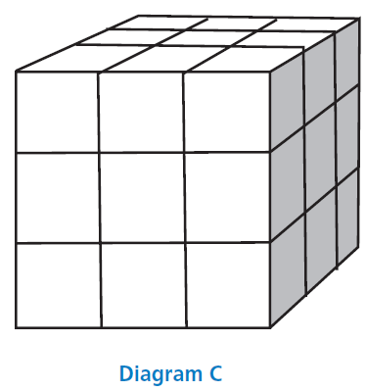

**QUESTION 34.3**Susan realises that she used more small cubes than she really needed to make a block like the one shown in Diagram C. She realises that she could have glued small cubes together to look like Diagram C, but the block could have been hollow on the inside.

What is the minimum number of cubes she needs to make a block that looks like the one shown in Diagram C, but is hollow?

What have we learned?

What other mathematical techniques do we need to apply?

What useful information do we know?

**REMEMBER**! Accuracy and spelling of key words * Appropriate paragraphing and sequencing of information presented * Correct phrasing – capitals, punctuation.

What do we want to find out?

Mathematics Unit 34: Building Blocks

Workings and final answer.

  **QUESTION 34.4**  
Now Susan wants to make a block that looks like a solid block that is 6 small cubes long, 5 small cubes wide and 4 small cubes high. She wants to use the smallest number of cubes possible, by leaving the largest possible hollow space inside the block.  
What is the minimum number of cubes Susan will need to make this block?