Workings and final answer.

What have we learned?

What other mathematical techniques do we need to apply?

What useful information do we know?

**REMEMBER**! Accuracy and spelling of key words * Appropriate paragraphing and sequencing of information presented * Correct phrasing – capitals, punctuation.

What do we want to find out?

Mathematics Unit 20: Test Scores

**QUESTION 20.1**The diagram below shows the results on a science test for two groups, labelled as Group A and Group B.  
The mean score for Group A is 62.0 and the mean for Group B is 64.5. Students pass this test when their score is 50 or above.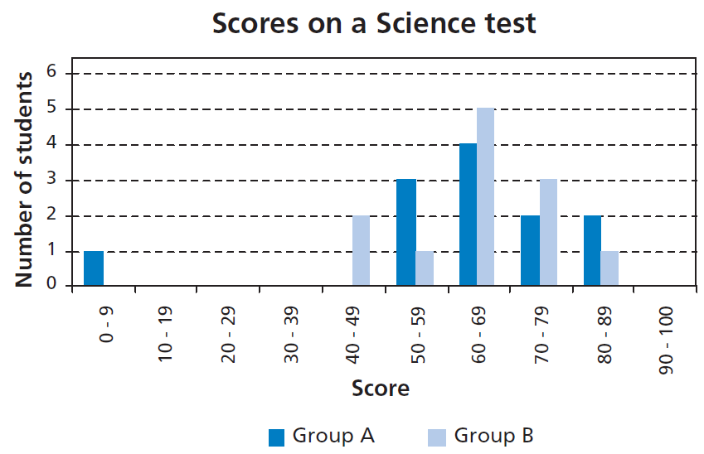  
Looking at the diagram, the teacher claims that Group B did better than Group A in this test.  
The students in Group A don’t agree with their teacher. They try to convince the teacher that Group B may not necessarily have done better.  
Give one mathematical argument, using the graph, that the students in Group A could use.