Workings and final answer.

What have we learned?

What other mathematical techniques do we need to apply?

What useful information do we know?

**REMEMBER**! Accuracy and spelling of key words * Appropriate paragraphing and sequencing of information presented * Correct phrasing – capitals, punctuation.

What do we want to find out?

Mathematics Unit 17: Litter

**QUESTION 17.1**

For a homework assignment on the environment, students collected information on the decomposition time of several types of litter that people throw away:

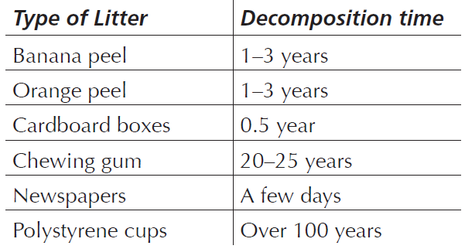

A student thinks of displaying the results in a bar graph. Give *one* reason why a bar graph is unsuitable for displaying these data.