Workings and final answer.

What have we learned?

What other mathematical techniques do we need to apply?

What useful information do we know?

**REMEMBER**! Accuracy and spelling of key words * Appropriate paragraphing and sequencing of information presented * Correct phrasing – capitals, punctuation.

What do we want to find out?

Mathematics Unit 13: Exports

The graphics below show information about exports from Zedland, a country that uses zeds as its currency.

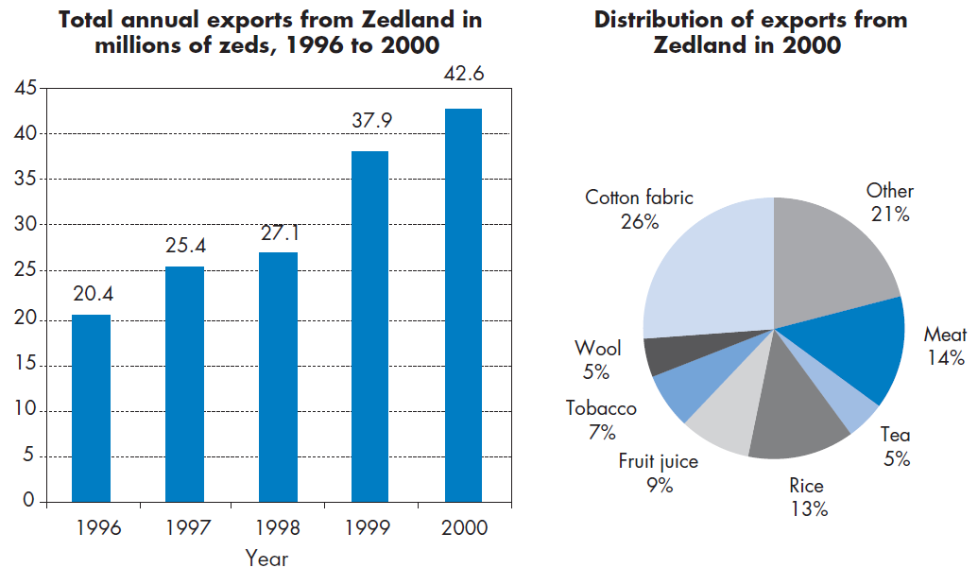**QUESTION 13.1**

What was the total value (in millions of zeds) of exports from Zedland in 1998?

**QUESTION 13.2**What was the value of fruit juice exported from Zedland in 2000?  
A. 1.8 million zeds.  
B. 2.3 million zeds.  
C. 2.4 million zeds.  
D. 3.4 million zeds.  
E. 3.8 million zeds.

Workings and final answer.

What have we learned?

What other mathematical techniques do we need to apply?

What useful information do we know?

**REMEMBER**! Accuracy and spelling of key words * Appropriate paragraphing and sequencing of information presented * Correct phrasing – capitals, punctuation.

What do we want to find out?

Mathematics Unit 13: Exports