Workings and final answer.

What have we learned?

What other mathematical techniques do we need to apply?

What useful information do we know?

**REMEMBER**! Accuracy and spelling of key words * Appropriate paragraphing and sequencing of information presented * Correct phrasing – capitals, punctuation.

What do we want to find out?

Mathematics Unit 10: Carpenter

**QUESTION 10.1**  
A carpenter has 32 metres of timber and wants to make a border around a garden bed. He is considering the following designs for the garden bed.  
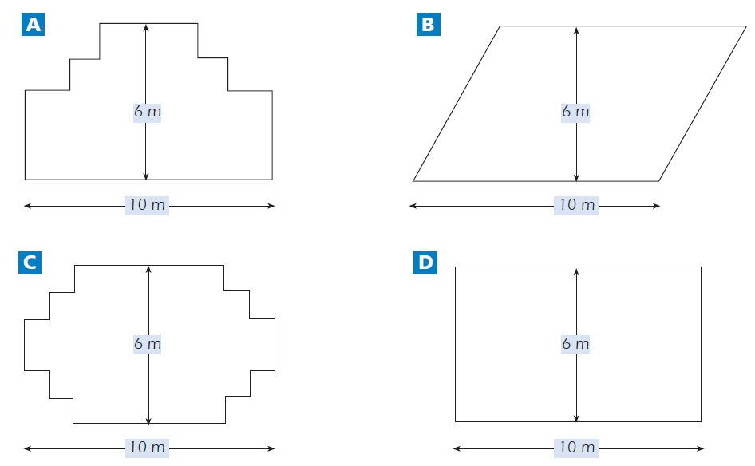  
Circle either “Yes” or “No” for each design to indicate whether the garden bed can be made with 32 metres of timber.  
