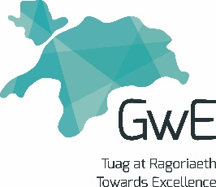
Welsh Baccalaureate Scheme of Learning-National

This Scheme of Learning has been designed to be used by teachers and tutors delivering the Welsh Baccalaureate Individual Project from September 2015.
Teaching Block 3b Numeracy 2
Learning Activity | Skills Developed | Resources | Differentiation | LO/Assessment
Collecting Primary Data.  Pupils to complete a mind map of the different techniques for collecting information.  Discuss when it is appropriate to use  - Questionnaires  - Interviews  - Observations  Examine good and bad examples of questionnaires and interview questions. Pupils to use highlighters (green and orange) to show the good and bad questions. | Team working  Identifying methods for collection of Primary data | A3 sheets of paper  Coloured pens / highlighters | By outcome | LO4
Using different methods for collecting data  Tell the pupils they have been asked to survey eating habits in the school canteen.  Pupils must work in a group and use all three methods for collecting data.  Questionnaires could be produced using IT e.g. Word, Survey Monkey or Google Forms. | Team working  Use different methods for collection of Primary data  Deciding how to collate the data collected  Using digital techniques to present tables, graphs and diagrams. | WJEC Good Practice guide to questionnaires (3.2)  Access to computers | Example questions could be given to pupils who need more help. | LO4,LO6

