Workings and final answer.

What have we learned?

What other mathematical techniques do we need to apply?

What useful information do we know?

**REMEMBER**! Accuracy and spelling of key words * Appropriate paragraphing and sequencing of information presented * Correct phrasing – capitals, punctuation.

What do we want to find out?

Mathematics Unit 49: Moving Walkways

**QUESTION 49.1**  
Below is a photograph of moving walkways.

The following Distance-Time graph shows a comparison between “walking on the moving walkway” and “walking on the ground next to the moving walkway.”

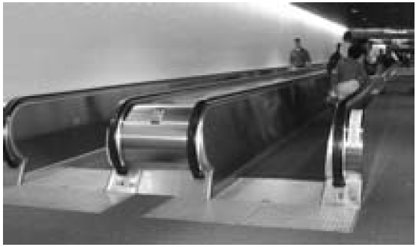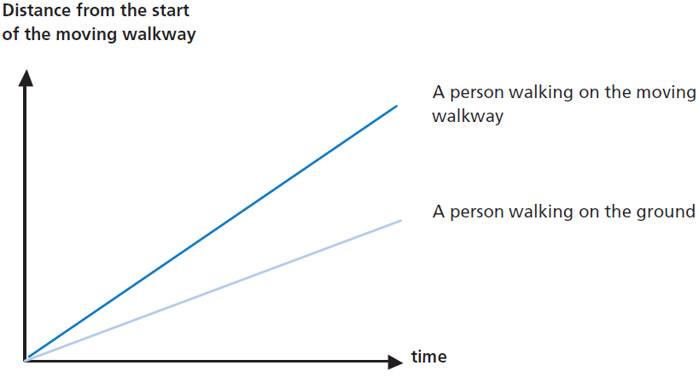

Assuming that, in the above graph, the walking pace is about the same for both persons, add a line to the graph that would represent the distance versus time for a person who is standing still on the moving walkway.