Workings and final answer.

What have we learned?

What other mathematical techniques do we need to apply?

What useful information do we know?

**REMEMBER**! Accuracy and spelling of key words * Appropriate paragraphing and sequencing of information presented * Correct phrasing – capitals, punctuation.

What do we want to find out?

Mathematics Unit 40: Payments by Area

People living in an apartment building decide to buy the building. They will put their money together in such a way that each will pay an amount that is proportional to the size of their apartment.

For example, a man living in an apartment that occupies one fifth of the floor area of all apartments will pay one fifth of the total price of the building.

**QUESTION 40.1**  
Circle Correct or Incorrect for each of the following statements.

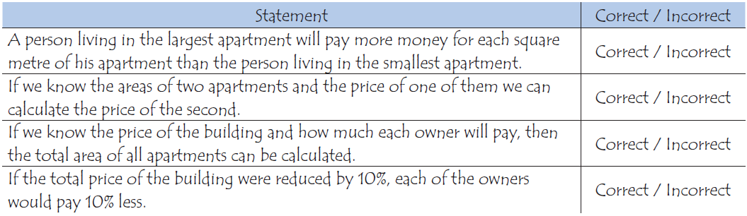

Workings and final answer.

People living in an apartment building decide to buy the building. They will put their money together in such a way that each will pay an amount that is proportional to the size of their apartment.

For example, a man living in an apartment that occupies one fifth of the floor area of all apartments will pay one fifth of the total price of the building.

**QUESTION 40.2**  
There are three apartments in the building. The largest, apartment 1, has a total area of 95m2. Apartments 2 and 3 have areas of 85m2 and 70m2 respectively. The selling price for the building is 300 000 zeds.  
How much should the owner of apartment 2 pay? Show your work.

What have we learned?

What other mathematical techniques do we need to apply?

What useful information do we know?

**REMEMBER**! Accuracy and spelling of key words * Appropriate paragraphing and sequencing of information presented * Correct phrasing – capitals, punctuation.

What do we want to find out?

Mathematics Unit 40: Payments by Area