http://www.bbc.co.uk/news/magazine-29307705
Document 2
Demanding justice for women and children abused by Irish nuns
By Sue Lloyd Roberts BBC News, Ireland

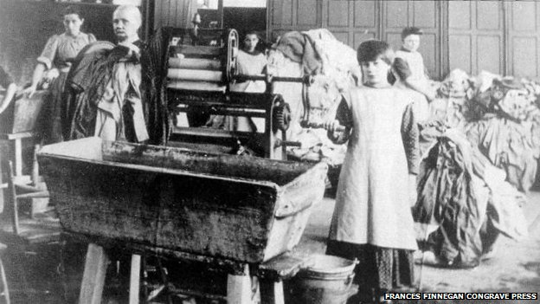

An inquiry last year into Ireland's Magdalene laundries, where for decades thousands of women were forced to work by nuns, found no evidence that workers were abused. But those who experienced life inside laundry walls angrily reject this, and are insisting that the nuns be held accountable.
"Oh my God! You know what? This brings back so much memories," 65-year-old Elizabeth Coppin says as she pushes open the door to the Convent Church next to the Magdalene laundry where she was sent to work for the nuns when she was 14.
"We used to have to go to confession once a week," she says, as we pass the confessional box. "The priest would sit in here and we would go in here to tell him our sins. But what sins did we have? We were working all the time. They were the sinners, not us. They were torturing us."
For decades, Ireland ignored the stories told by the former Magdalene laundry workers. After all, weren't people told by the priests that they were just fallen women, or the criminally insane, who deserved to be locked up for most of their adult lives and work, without pay, to atone for their sins?
Coppin had been abused by her stepfather and sent to an orphanage - one of a number of welfare institutions run by the church on behalf of the state. From there, still a child, she was passed into the network of Magdalene laundries and forced to work from eight to six every day except Sundays and bank holidays.
In one of these, in Cork, she was wrongly accused of stealing sweets and held for three days in a punishment cell, without a bed or mattress. But that was nothing compared to the punishment she faced for trying to run away. She was sent to another laundry, with an even stricter regime.
"They changed my name to Enda, a man's name. They shaved my head and I had to wear a uniform. So straight away your identity is taken because my name is changed, my hair is cut and I'm not wearing my own clothes," she says.
"And I'm stuck in there and I have to answer to the name Enda, which is a man's name. How do you cope with that at that age?"
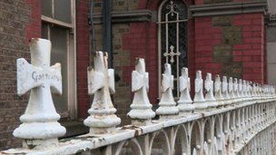
Elizabeth Coppin and Mary Merrit share their stories in Our World: Ireland's Hidden Bodies, Hidden Secrets on Saturday 27 and Sunday 28 September at 21:30 BST on BBC World News, and today on Newsnight on BBC2.
It was not until Coppin and others went to the United Nations Committee Against Torture (UNCAT), which in turn put pressure on the Irish government to investigate, that Senator Martin McAleese, a former member of the Irish Senate and a devout Roman Catholic, was asked to head an inquiry into what exactly had happened behind the convent walls.
Survivors were astounded to read in his report that "ill treatment, physical punishment and abuse… was not something experienced in the Magdalene laundries".
The government has now called another inquiry into what happened at another church-run institution, the Mother and Baby homes for unmarried mothers, after it was revealed earlier this year that nearly 800 young children had been buried in unmarked graves from 1925-1961 at a convent in the west of Ireland. Some remains were found in a concrete tank.
So the Magdalene laundry survivors are asking for this latest inquiry to have a wide remit, and to investigate the laundries again.
"I would love them to get to the real truth, but they won't," says Coppin. "They won't inquire properly because I know what the government are like."
Eighty-three-year-old Mary Merritt is a survivor of both a Mother and Baby Home and a Magdalene laundry. Born in one, to a single mother, she ended up in a laundry after years in an orphanage - all three institutions run by nuns.

High Park Laundry in Dublin, where Mary Merritt was sent to work
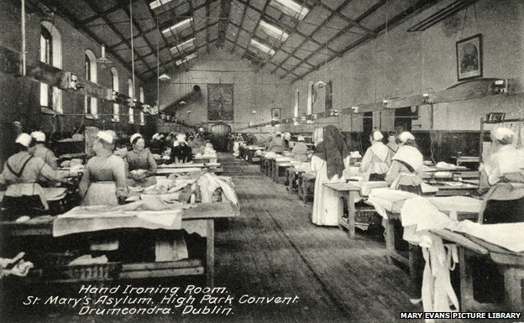

"I was in one of the orphanages, which they called industrial schools in those days. I was so hungry that I stole some apples from the orchard. The nuns told me that they had found a 'situation' for me and sent me to the High Park Laundry in Dublin and told me that I had to stay there until I learned not to steal. They kept me there as an unpaid worker for 14 years. You don't even get that for murder these days."
She remembers that the work was so hard and the regime so cruel that she broke a window and ran away in to the town where she asked a priest for help. The priest raped her. The nuns did not believe her when she was picked up by the police and returned to the laundry.
She was put in the windowless punishment cell, a room two metres square. "One of the nuns came down there and she cut my hair to the bone and then I was taken up and I was made to kneel in a room with all the women there, kneel down, kiss the floor and say I was sorry for what I did and promise not to run away again which I didn't promise, of course."
The McAleese report concludes that the median stay for women in the laundries was seven months. "Nonsense!" says Mary as we go together to visit a mass grave of former Magdalene High Park Laundry workers at Glasnevin, the main cemetery in Dublin.
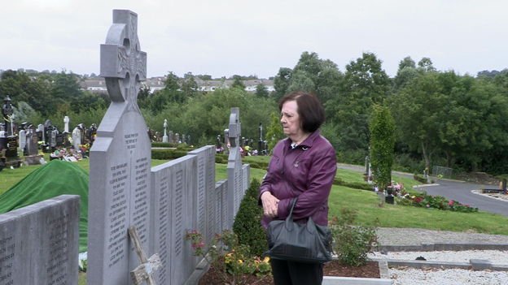
"I was in the laundry for 14 years and I know at least one woman, my best friend, buried here who was there for more than 50," she says pointing to the name Mary Brehany who is among 160 names on the slabs of granite.

Researchers from the Magdalene Names Project told us that according to their research into a 10-year period (1954 to 1964) at the High Park Laundry, most women were there for at least eight years.
The McAleese report also claims that the laundries never made a profit - another idea treated with derision by the women. "It was slave labour," says Coppin, who spent four years in three laundries.
"The nuns had contracts with all the local hotels and businesses as well as all the convents and seminaries." It is hard to check the "not for profit" assertion because the accounts submitted to the inquiry by the religious orders, prepared by their own accountants, are not open to public scrutiny.
However, we found a ledger belonging to the High Park Laundry in the Little Museum in Dublin, dating back to 1980. Meticulously kept accounts show that their clients included convents and restaurants as well as the airport, the main railway station in Dublin and government ministries. No wonder Trade Unions and commercial laundries complained at the time. They were having to compete for business with the nuns who could rely on free, forced labour.
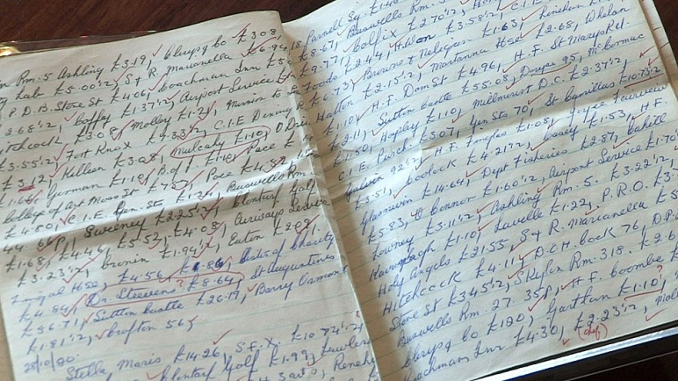

The Irish Examiner newspaper, which has investigated the finances of the religious orders involved in running the laundries, says they owned assets in 2012 of 1.5bn euros ($1.9bn, £1.2bn).
The wealth of the nuns is a running sore, not only with the survivors who feel they have been so unfairly exploited, but increasingly with the Irish taxpayer. Despite the shortcomings of the McAleese report, the government has apologised for the suffering of the women and appointed much-respected Judge John Quirke to implement a compensation scheme. He has won favour with the survivors who say that at least he listens to them.
The final bill for compensation is likely to exceed 150m euros ($190m, £120m) and yet the religious orders have refused to contribute. I asked the Deputy Prime Minister, Joan Burton, why the government was not putting pressure on the nuns to pay up.
"There is a conversation ongoing with the religious orders to make contributions appropriate to the total amount of money that has been spent by the state," she said. So she will be putting on pressure? "That's a continuing conversation, yes."
No-one is holding their breath. The government has made four formal requests for contributions to the four religious orders involved in running the laundries and they have not been forthcoming.
Will the government listen to the grievances of the laundry survivors and broaden the new inquiry to include them? "Well it will include relevant elements," says Burton, "but, we haven't finalised the actual terms of reference yet."
The Magdalene laundry survivors are not optimistic. "Nobody talks about the violation of women here, the religious ideology is so ingrained in Irish society," says Elizabeth Coppin
"I want somebody to tell the truth and to apologise," says Mary Merritt, "the nuns, the church, the priests... just somebody to apologise to me before I die."

