POVERTY

Global Citizenship Challenge
CONTROLLED ASSESSMENT
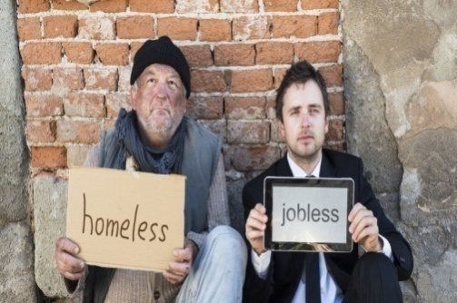
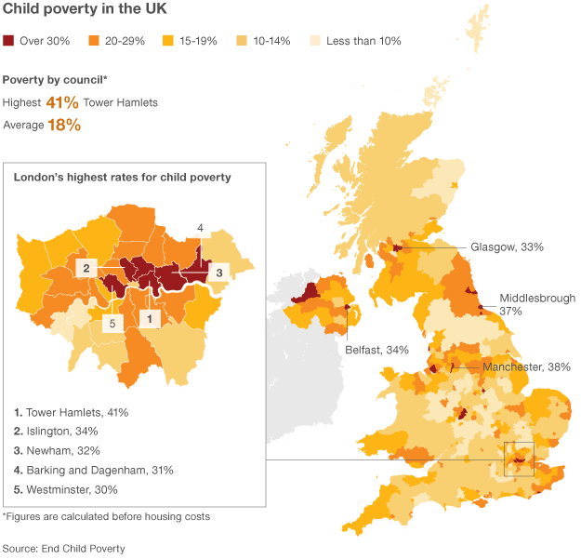

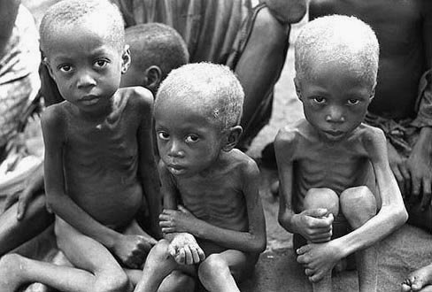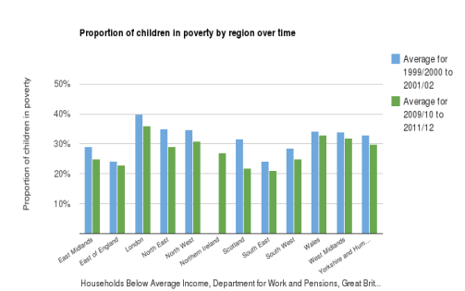

GLOBAL CITIZENSHIP CHALLENGE
Raising Awareness of Poverty

PURPOSE
The purpose of the Global Citizenship Challenge is to develop learners’ skills, whilst providing opportunities to understand and respond appropriately to global issues. During the Global Citizenship Challenge learners will explicitly develop skills of Critical Thinking and Problem Solving and Creativity and Innovation and apply them in an appropriate manner.

TASKS
Flintshire County Council is inviting young people to a conference to give their viewpoint on poverty. Before the event each student in Year 10 is being asked to write a report in preparation for sharing their ideas.
Each student is also being asked to decide on the best way to raise awareness of poverty as a global issue.

PREPARATION
Make sure you read through the notes you have made in class over the last few weeks.

TASKS
1. Develop and present a written Personal Standpoint on poverty including:
- facts, factors, differing opinions and viewpoints including those of peers;
- consideration of the credibility of sources used;
- relevant factors – political, economic, social, technological, legal and environmental (PESTLE).
2. Develop and implement Raising Awareness activity on poverty for the Flintshire County Council conference.
Produce on an individual basis a Raising Awareness Pack which could include evidence demonstrating the:
- generation and evaluation of ideas for raising awareness;
- selection of one idea;
- development and implementation of the idea including appropriate problem solving and decision making techniques;
- materials and resources to be used in the raising awareness activity.
3. Produce a Personal Review of the raising awareness activity including:
- development and application of Critical Thinking and Problem Solving;
- development and application of Creativity and Innovation.

