Creating Resources
for
English Language
Reading

Creating Resources
For some teachers, creating resources can be a favourite part of the job; for others, it can be the worst! This guide should lead you through task setting, source choice, and question wording in preparation for the new GCSE English Language. The aim is to be comprehensive, not patronising, so dip in and out as you see fit.
There are a number of ways that you can create resources for the new specification, but the most effective way is to start with the task – the actual skill that you want to test. From there, choosing your resource is the next logical step and then, once you have your components, you phrase the question to marry the two.

This guide will take you through these key steps, taking a closer look at the specification, and using it to create new resources that will engage students whilst preparing them for the new examinations.

A great place to start is Guy Melhuish’s video on the new specification, found on YouTube at: https://www.youtube.com/watch?v=nltBuWzkAZ4#action=share

Task Setting

Source Choice

Question Wording

Task Setting
For AO2 Reading, according to the new specification, students are expected to:
- Use inference and deduction skills to retrieve and analyse information from a wide range of written texts;
- Synthesise and summarise information from a range of texts;
- Interpret themes, meaning, ideas, and information in a range of texts and challenging writing;
- Edit texts, and compare and evaluate the usefulness, relevance, and presentation of content within or across texts;
- Refer to evidence within texts, distinguishing between statements that are supported by evidence and those that are not;
- Evaluate and reflect on the ways in which texts may be interpreted differently according to the perspective of the reader, and distinguishing between facts or evidence and opinions, bias and argument;
- Understand and recognise the purpose and reliability of texts, for example - texts for personal, public, occupational, and educational use.

Task Setting
As the two exams (Units 2 and 3) are testing a series of reading skills, it is important to set tasks that develop each skill in turn. As the students become more confidence in targeting each skill, then you will be able to become more creative in the way that you approach task setting. Using the following table will be a key way to ensure that each AO2 skill is reached.
Reading Skills Required in  UNIT 2 & UNIT 3 ENGLISH G.C.S.E. | Reading Literacy PISA Framework
Respond, reflect and analyse a wide range of written texts (continuous and non-continuous). | Integrating and interpreting involves processing what is read to make sense of a text. | Continuous texts are formed by sentences organised into paragraphs, e.g. Newspaper reports, essays, novels, short stories, and reviews and letters.  Non-continuous: as the sentences are the smallest unit of continuous texts, all non-continuous texts can be shown to be composed of a number of lists (Kirsch and Mosenthal, 1990), e.g. lists, tables, graphs, diagrams, advertisements, schedules, catalogues, indexes and forms.  Mixed texts consist of a set of elements in both a continuous and non-continuous format. Mixed text is a common format in magazines, reference books and webpages.
Analyse and respond to texts and their subtexts, using inference and deduction and linking ideas within and across texts. | Compare and contrast tasks require students to draw together two or more pieces of information from the text. In order to process either explicit or implicit information from one or more sources in such tasks, the reader must often infer an intended relationship or category.
Demonstrate independence in synthesising and summarising information effectively from a range of texts. | Requires students to stand apart from the text, to consider it objectively and to evaluate its quality and appropriateness.
Interpret themes , meanings, ideas and information in a range of texts and challenging writing; reading in different ways for different purposes, and comparing and evaluating the usefulness, relevance and presentation of content | Some tasks might require the student to identify a specific piece of text, when a theme or main idea is explicitly stated. Other tasks may require the student to focus on more than one part of the text. Such tasks indicate whether the student can distinguish between key ideas and minor details.
Support point of view by referring to evidence within texts; identifying bias and distinguishing between statements that are supported by evidence and those that are not. | Some tasks may require students to make inferences about the author’s intention, and to identify the evidence used to infer that intention. Students will also be required to make meaning from something that is not explicitly stated, and recognise or identify a relationship that is not explicit. Students may also be required to assess the relevance of particular pieces of information or evidence.
Evaluate and reflect on the ways in which texts may be interpreted differently according to their perspective of the reader and distinguishing between facts or evidence and opinions, bias and argument. | Reflecting on and evaluating the content of a text requires the reader to connect information in a text to knowledge from outside sources. Readers must also assess the claims made in a text against their own knowledge of the world. To do so, readers must be able to develop an understanding of what is said and intended in a text.
Understand and recognise the purpose and reliability of texts, e.g. texts for personal, public, occupational and educational use. | Students may be required to reflect on and evaluate the form of a text including determining the usefulness of a particular text for a specified purpose and evaluating an author’s use of particular features in accomplishing a particular goal. | Personal relates to texts that are intended to satisfy an individual’s personal interests, both practical and intellectual. E.g. personal letters, fiction, biography and informational texts that are intended to be tread to satisfy curiosity. In the electronic medium it includes emails, instant messages, social media/networking sites, and diary style blogs.  Public relates to activities and concerns of the larger society. E.g. Official documents and information about public events. In general, the texts associated with this category assume a more or less anonymous contact with others; they also therefore include forum-style blogs, news websites and public notices.  Educational relates to texts usually designed specifically for the purpose of instruction. Printed textbooks and interactive software are typical examples.  Occupational reading often involves a task that involves the accomplishment of some immediate task. E.g. searching for job or following workplace directions.
Demonstrate verbal reasoning skills in synthesising and summarising information from a range of texts. | Students may be required to offer or identify alternative pieces of information to strengthen an author’s argument, or evaluate the sufficiency of the evidence or information provided in the text. | Verbal reasoning often refers to more complex thinking tasks such as analytical, synthesis and evaluation, solving problems through reasoning with words and language.

Source Choice
Unit 2 and Unit 3 will present students with continuous and non-continuous texts.
Unit 2  Description, Narration, Exposition  CONTINUOUS –  Autobiography  Biography  Diary  Speech  Reportage  Travel writing  Journalism  High-quality reviews  Extracts from novels  Extracts from short stories  NON-CONTINUOUS –  adverts, diagrams, lists, graphs, schedules, tables. | Unit 3  Argumentation, Persuasion, Instructional  CONTINUOUS –  Letters  Emails  Fact sheets  Leaflets  Articles  Reports  Blogs  Notices  Guides  Manuals  Digital/Multi-modal texts  NON-CONTINUOUS –  adverts, diagrams, lists, graphs, schedules, tables.

Ensuring that students become experienced in working with each type of text should eliminate any surprises from the examination. Ideally, each Unit’s text types should be studied in turn, for example, looking at a range of Unit 2 texts over a set period of time, then looking at a range of Unit 3 text types. It is important that students know the types of texts to expect for each examination.

Some Source Examples – Unit 2 – Continuous
Autobiography – My Side, David Beckham

Biography – Steve Jobs - The Exclusive Biography, Walter Isaacson
Speech – I have a dream, Martin Luther King
I am happy to join with you today in what will go down in history as the greatest demonstration for freedom in the history of our nation.
Five score years ago, a great American, in whose symbolic shadow we stand today, signed the Emancipation Proclamation. This momentous decree came as a great beacon light of hope to millions of Negro slaves who had been seared in the flames of withering injustice. It came as a joyous daybreak to end the long night of captivity.
But one hundred years later, the Negro still is not free. One hundred years later, the life of the Negro is still sadly crippled by the manacles of segregation and the chains of discrimination. One hundred years later, the Negro lives on a lonely island of poverty in the midst of a vast ocean of material prosperity. One hundred years later, the Negro is still languished in the corners of American society and finds himself in exile in his own land. So we have come here today to dramatize a shameful condition.

Reportage – from The Independent, Roisin O’Connor
Finland to remove cursive handwriting from education curriculum
The move has sparked debate over the future of handwriting in the classroom
Cursive handwriting will be scrapped from the Finnish education curriculum and replaced by lessons in keyboard typing, it has been announced.
The country’s education board said that the change - set to take effect in 2016 - will reflect how typing skills are more relevant than handwriting. The move has sparked debate over the future of handwriting in the classroom.
Minna Harmanen from the National Board of Education told Finnish publication Savon Sanomat that "fluent typing skills are an important national competence".
In September 2013 cursive handwriting was removed as a compulsory skill in the US, where 43 states have adopted the standard as of last year.
Misty Adoniou, senior lecturer of Language, Literacy and TESL at the University of Canberra, told The Independent: "I think they [Finland] have made a sensible decision, and it has probably come about from a sensible curriculum review.
"Cursive writing is a reflection of a time when we used a fountain pen and ink - a writing technology.
"Nobody is arguing that children shouldn't learn to write by hand. However writing technologies have continued to evolve and most of us use a keyboard of some kind to most of our written communication, so it does make sense to spend some time at school ensuring children have those keyboard skills."

Travel Writing – Notes from a Small Island, Bill Bryson
I took a train to Liverpool. They were having a festival of litter when I arrived. Citizens had taken time off from their busy activities to add crisp packets, empty cigarette boxes and carrier-bags to the otherwise bland and neglected landscape. They fluttered gaily in the bushes and brought colour and texture to pavements and gutters. And to think that elsewhere we stick these objects in rubbish bags.
In another bout of extravagant madness, I had booked a room in the Adelphi Hotel. I had seen it from the street on earlier visits and it appeared to have an old-fashioned grandeur about it that I was keen to investigate. On the other hand, it looked expensive and I wasn't sure my trousers could stand another session in the trouser press. So I was most agreeably surprised when I checked in to discover that I was entitled to a special weekend rate and that there would be money spare for a nice meal and a parade of beer in any of the many wonderful pubs in which Liverpool specializes.
And so, soon afterwards, I found myself, like all fresh arrivals in Liverpool, in the grand and splendorous surroundings of the Philharmonic, clutching a pint glass and rubbing shoulders with a happy Friday-evening throng. The Phil (you can call it this if you have been there twice) was in fact a bit too crowded for my liking. There was nowhere to sit and scarcely any room to stand, so I drank two pints, just enough at my time of life to need a pee - for there is no place in the world finer for a pee than the ornate gents' room of the Philharmonic - then went off to find some place a little quieter.

Extract from novel – Rebecca, Daphne Du Maurier
Last night I dreamt I went to Manderley again. It seemed to me I stood by the iron gate leading to the drive, and for a while I could not enter, for the way was barred to me. There was a padlock and a chain upon the gate. I called in my dream to the lodge-keeper, and had no answer, and peering closer through the rusted spokes of the gate I saw that the lodge was uninhabited. No smoke came from the chimney, and the little lattice windows gaped forlorn. Then, like all dreamers, I was possessed of a sudden with supernatural powers and passed like a spirit through the barrier before me.
The drive wound away in front of me, twisting and turning as it had always done, but as I advanced I was aware that a change had come upon it; it was narrow and unkept, not the drive that we had known. At first I was puzzled and did not understand, and it was only when I bent my head to avoid the low swinging branch of a tree that I realized what had happened. Nature had come into her own again and, little by little, in her stealthy, insidious way had encroached upon the drive with long, tenacious fingers.
The woods, always a menace even in the past, had triumphed in the end. They crowded, dark and uncontrolled, to the borders of the drive. The beeches with white, naked limbs leant close to one another, their branches intermingled in a strange embrace, making a vault above my head like the archway of a church. And there were other trees as well, trees that I did not recognize, squat oaks and tortured elms that straggled cheek by jowl with the beeches, and had thrust themselves out of the quiet earth, along with monster shrubs and plants, none of which I remembered.

Some Source Examples – Unit 3 – Continuous
Letter –
Email –
Blog – To Engage Them All
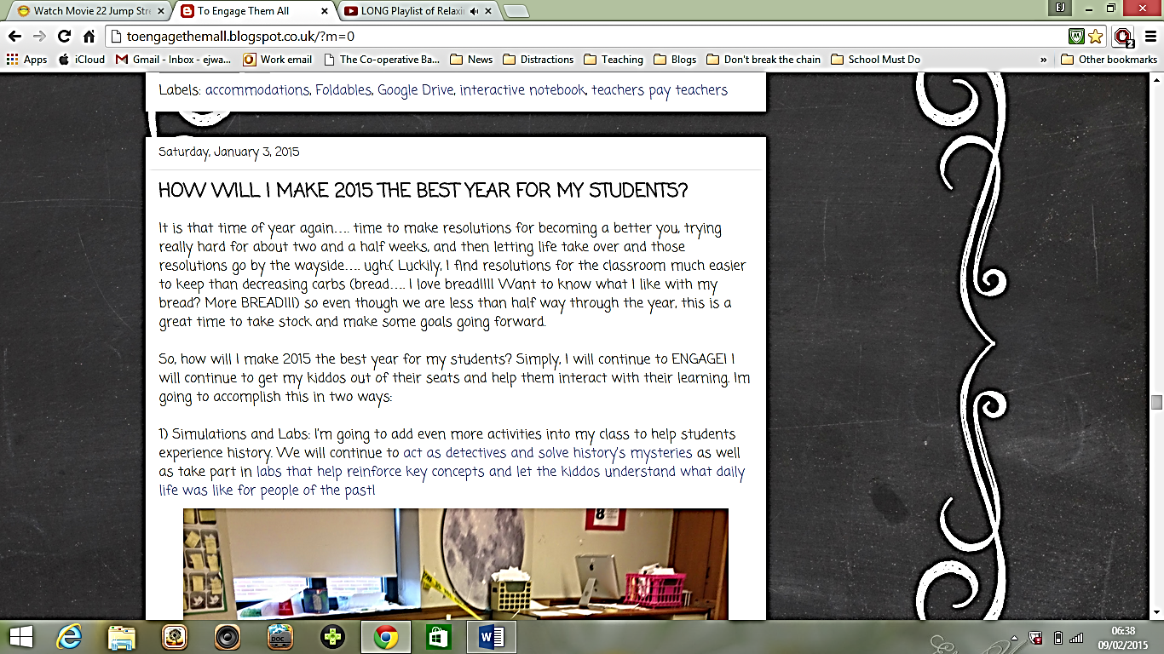

Guide –
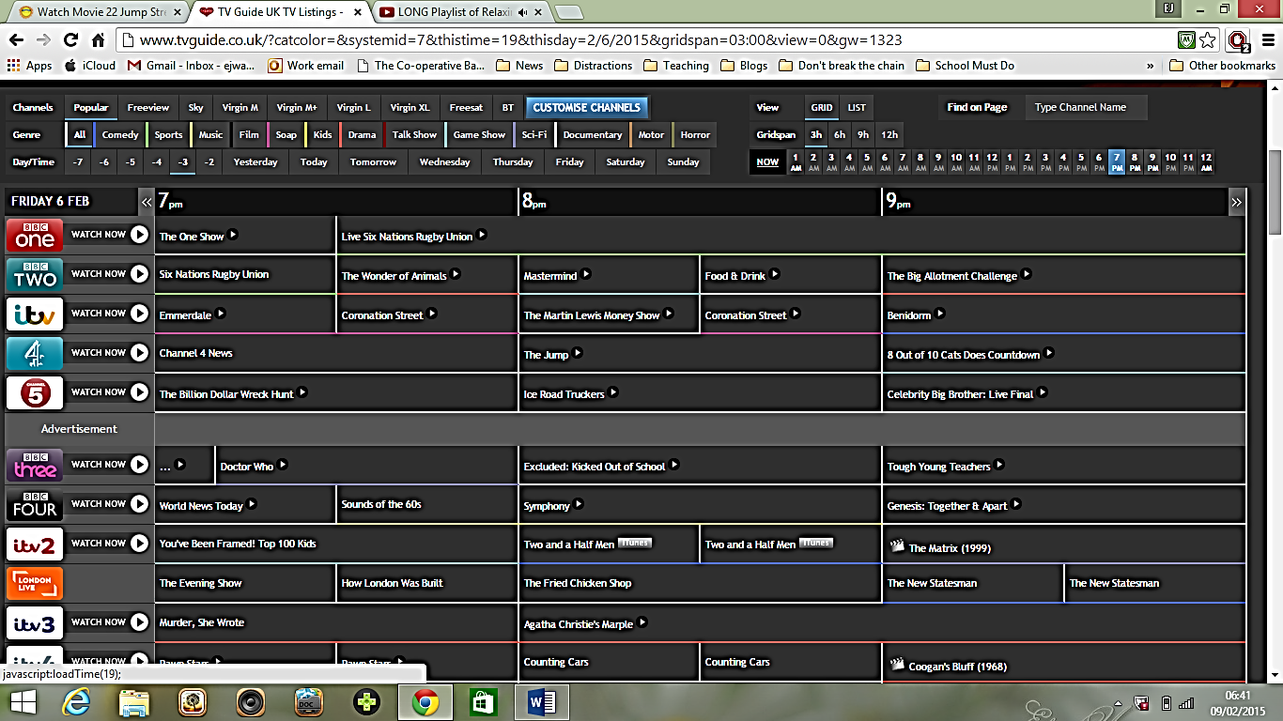
Units 2 and 3 – Non-Continuous
Advert –

Diagram –
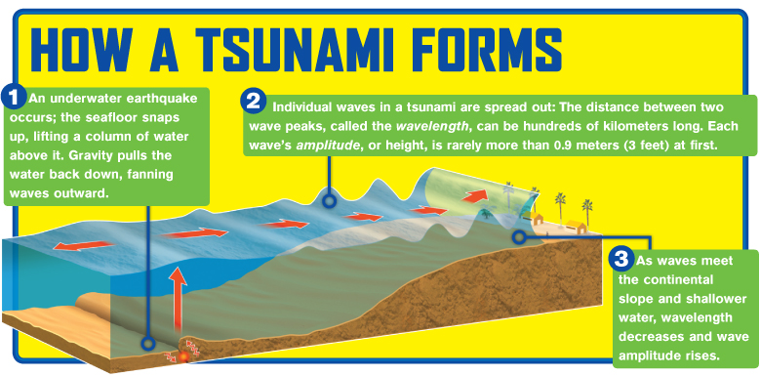

Graph –
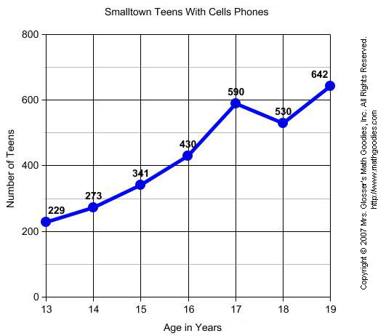
List –
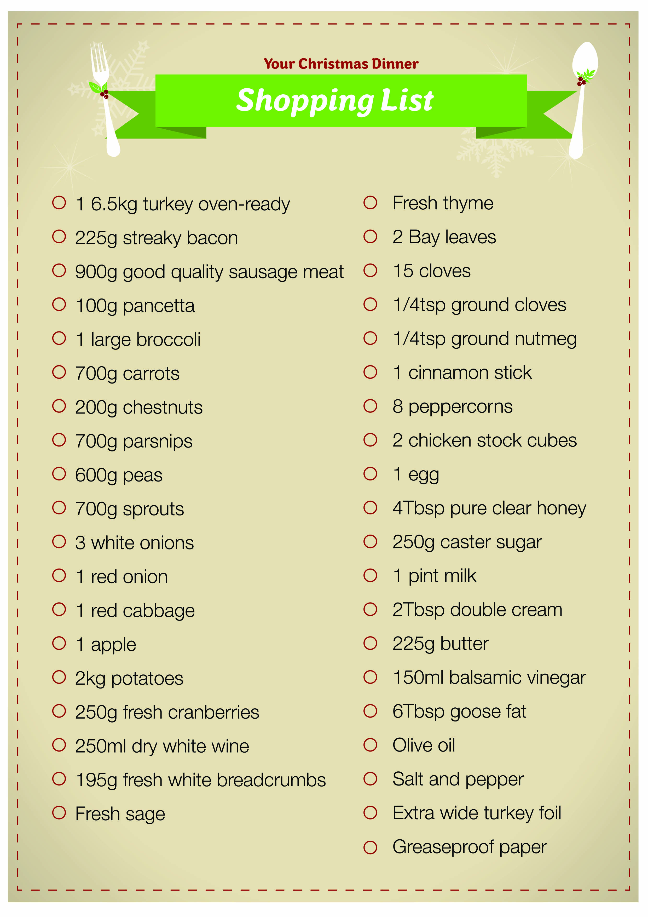

Table –
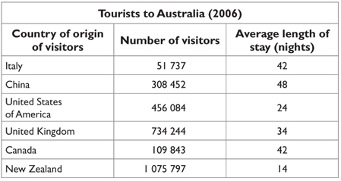

Question Wording –

- There will be a variety of question types on each paper.
- The length of responses will vary, and the available marks will also vary, according to the question.
- There will be a minimum of three multiple choice questions in each paper, each offering four or five options from which to select.
- There will be one synthesis and one comparison question across the two papers – they might both be in one, or they could be in either.
- There will be questions on definitions, testing interpretation of meaning.
- There will be ‘how’ questions, looking at a writer’s choice of language.
- On Unit 2 there will be an editing task, where students will have to fill in words and look at sentence orders, etc.
- There will be questions looking at writers’ intentions, e.g. to persuade, etc.
- There will be questions that ask students to select facts, showing that they can distinguish between facts and opinion, bias, and arguments.

