Writing your Rationale
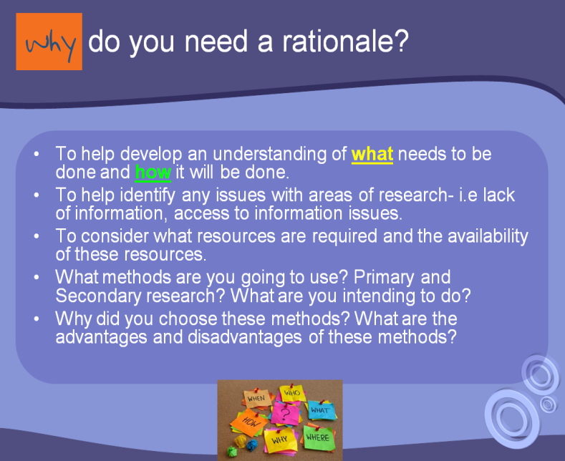
1: What is a rationale?
2. TO ACHIEVE YOUR AIM 1 -
What will you do? (Type of research)
How will you do it? (Research methods)
What resources will you need?
Why have you chosen to do it this way?
How will this help you?
3. TO ACHIEVE YOUR AIM 2 -
What will you do? (Type of research)
How will you do it? (Research methods)
What resources will you need?
Why have you chosen to do it this way?
How will this help you?
4. TO ACHIEVE YOUR AIM 3 -
What will you do? (Type of research)
How will you do it? (Research methods)
What resources will you need?
Why have you chosen to do it this way?
How will this help you?
5. Final task: Now use these answers to help you write up your rationale in your individual project Word document.

