Task 1.
Look at the user area below, there are a number of issues with it. Can you identify them?
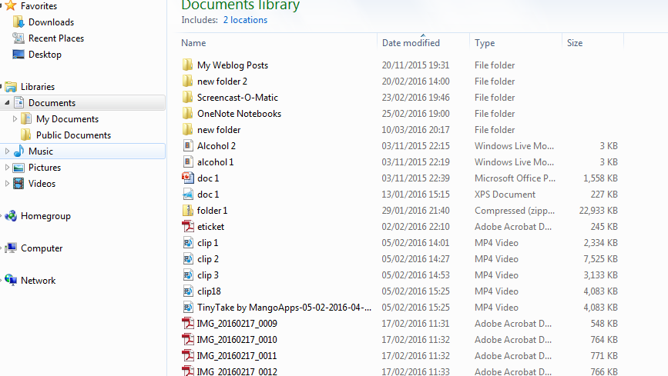
Document names are unhelpful.
Lots of documents are out of folders or subfolders
Some files are too big
Task 2.
Creating a manageable and organised work area. Below is a suggested plan of folders for the Individual Project. You will need to create your own organised area.

Task 3
It is essential you back your work up. You can do this in a number of ways these include:
- USB/ flash pen
- OneNote
- Dropbox (available in some centres)
- Googledrive
 | USB | OneNote | Dropbox | Googledrive
Pro | Low cost  Totally portable no reliance on internet access | Industry standard system  Access to full Microsoft office suit via OneNote  Have 2 way communication | Centre specific  Often only one way communication | Offers a range of apps  Can be accessed anywhere via internet
Cons | Volatile- can corrupt easily.  Must eject safely to protect.  Easily lost | Needs internet connection to sync  Conflict pages can cause confusion  Need access to software | Centre specific  Some cannot access outside of centre | Needs internet connection

Each option has pros and cons. Take part in a group discussion considering the pros and cons of each method of storage.
You need to select your back up method and set up the folders required for this.

