Task 1.
Look at the user area below, there are a number of issues with it. Can you identify them?
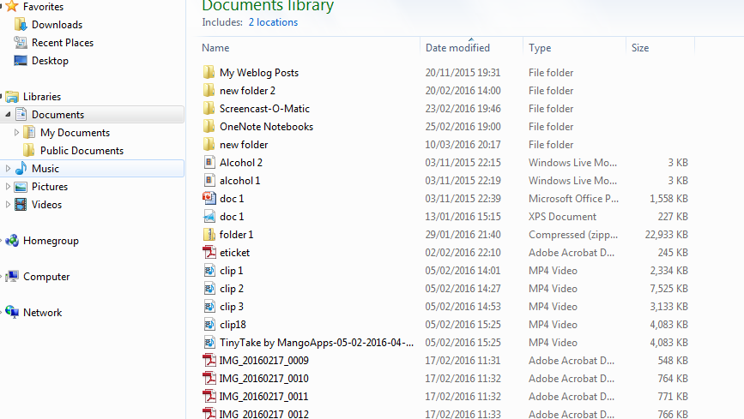

Task 2.
Creating a manageable and organised work area. Below is a suggested plan of folders for the Individual Project. You will need to create your own organised area.

Task 3
It is essential you back your work up. You can do this in a number of ways these include:
- USB/ flash pen
- OneNote
- Dropbox (available in some centres)
- Googledrive
Each option has pros and cons. Take part in a group discussion considering the pros and cons of each method of storage.
You need to select your back up method and set up the folders required for this.

