Lesson 1 Career Idea
For this project, you have to come up with a research activity in an area of personal interest – your career. This project requires you to write a 1000 – 2000 word essay therefore this lesson requires you to research possible careers that you might be interested in.
The Task:
Have a look on the internet at three possible career industries / area of work that you may have interest in as a possible career (don’t forget that you can use the image below to help you with some ideas). Complete the tables below on each industry as this will help you identify a suitable topic that you can research your project on.
If you find any research that you think might be important for this project, save it to your secondary research folder so that you can use it again in the future.
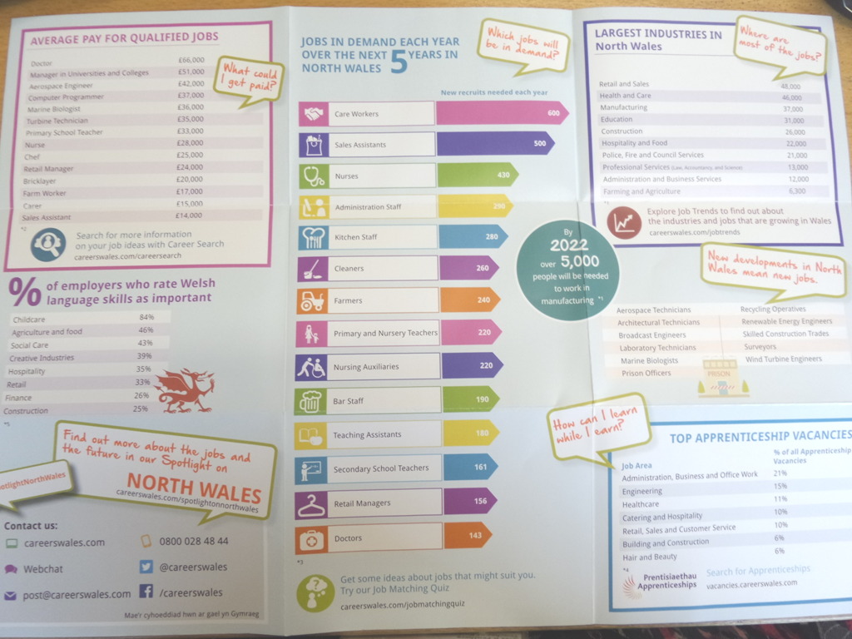
Complete the questions below:
Career Industry / Areas of Work 1
- State the career industry / area of work that may be of an interest to you
- Research the internet about this industry / area of work. Write a summary of what this industry / area of work is about.
- Source (record) any useful websites that you might be able to use for this project for this area of work (copy and paste the website address).
- Why do you think this industry would be a good career for you?

Career Industry / Area of Work 2
- State the career industry / area of work that may be of an interest to you
- Research the internet about this industry / area of work. Write a summary of what this industry / area of work is about.
- Source (record) any useful websites that you might be able to use for this project for this area of work (copy and paste the website address).
- Why do you think this industry would be a good career for you?

Career Industry / Area of Work 3
- State the career industry / area of work that may be of an interest to you
- Research the internet about this industry / area of work. Write a summary of what this industry / area of work is about.
- Source (record) any useful websites that you might be able to use for this project for this area of work (copy and paste the website address).
- Why do you think this industry would be a good career for you?

