Republic
Kaiser
Democracy
Dictatorship
Abdicate
Armistice
Weimar
Constitution
Proportional Representation
Reichstag
Communists
Freikorps
Match up the key word with the correct definition.

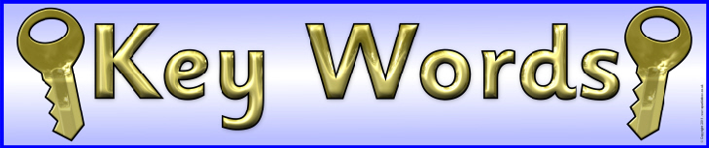
System of government based on freedom and equality. | Believers in the ideas of Karl Marx. Economic system built around public ownership | Voting system in which parties win seats in relation to the percentage of votes they win. | A town in Germany which gave it’s name to the new Republic.
The German Emperor. | Ex soldiers with extreme beliefs | A country without a monarch. | German Parliament.
To give up the throne. | A government where one person has total power and does not allow any opposition. | A cease fire. | The laws of a country, by which it is governed, written down in a document.

