QUESTION 1
Examiner only
This question is about crime and corruption.
Study the source below and then answer the question which follows.
Source A
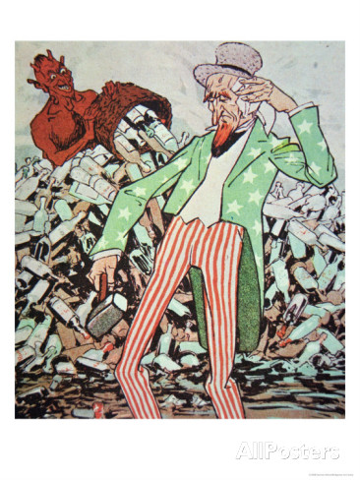

[A cartoon showing Uncle Sam exhausted by the devil’s flow of bootleg liquor]

Use Source A and your own knowledge to describe the end of the Prohibition.
[6]
--------------------------------------------------------------------------------------------------------------------------------------------------------------------------------------------------------------------------------------------------------------------------------------------------------------------------------------------------------------------------------------------------------------------------------------------------------------------------------------------------------------------------------------------------------------------------------------------------------------------------------------------------------------------------------------------------------------------------------------------------------------------------------------------------------------------------------------------------------------------------------------------------------------------------------------------------------------------------------------------------------------------------------------------------------------------------------------------------------------
Turn over.
--------------------------------------------------------------------------------------------------------------------------------------------------------------------------------------------------------------------------------------------------------------------------------------------------------------------------------------------------------------------------------------------------------------------------------------------------------------------------------------------------------------------------------------------------------------------------------------------------------------------------------------------------------------------------------------------------------------------------------------------------------------------------------------------------------------------------------------------------------------------------------------------------------------------------------------------------------------------------------------------------------------------------------------------------------------------------------------------------------------------------------------------------------------------------------------------------------------------------------------------------------------------------------------------------------------------------------------------------------------------------------------------
Examiner only

QUESTION 2
Examiner only
This question is about popular entertainment.
Describe the impact of Jazz on American culture in the 1920s. [8]
----------------------------------------------------------------------------------------------------------------------------------------------------------------------------------------------------------------------------------------------------------------------------------------------------------------------------------------------------------------------------------------------------------------------------------------------------------------------------------------------------------------------------------------------------------------------------------------------------------------------------------------------------------------------------------------------------------------------------------------------------------------------------------------------------------------------------------------------------------------------------------------------------------------------------------------------------------------------------------------------------------------------------------------------------------------------------------------------------------------------------------------------------------------------------------------------------------------------------------------------------------------------------------------------------------------------------------------------------------------------------------------------------------------------------------------------------------------------------------------------------------------------------------------------------------------------------------------------------------------------------------------------------------------------------------------------------------------------------------------------------------------------------------------------------------------------------------------------------------------------------------------------------------------------------------------------------------------------------------------------------------------------------------------------------------------------------------------------------------------------------------------------------------------------------------------------------------------------------------------------------------------------------------------------------------------------------------------------------------------------------------------------------------------------------------------------------------------------------------------------------------------------------------------------------------------------------------------------------------------------------------------------------------------------------------------------------------------------------------------------------------------------------------------

QUESTION 3
This question is about Role of Women.
Study the source below and then answer the question which follows.
Source B
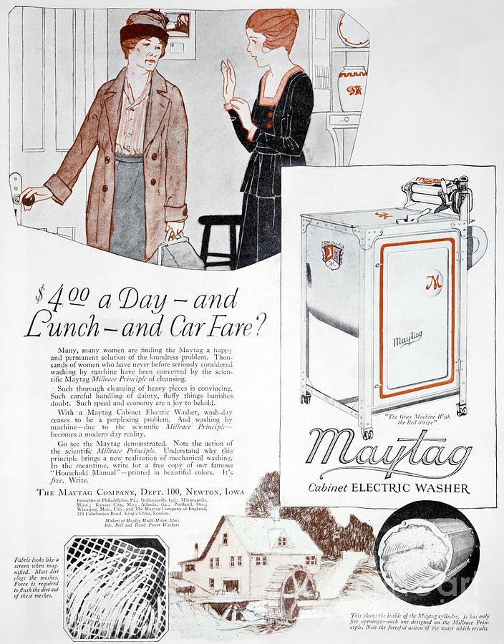

[American magazine advertisement in 1926 for the Maytag electric washing machine]

What was the purpose of Source B? [8]

[Use details from Source B and your own knowledge and understanding of the historical context to answer the question.]

------------------------------------------------------------------------------------------------------------------------------------------------------------------------------------------------------------------------------------------------------------------------------------------------------------------------------------------------------------------------------------------------------------------------------------------------------------------------------------------------------------------------------------------------------------------------------------------------------------------------------------------------------------------------------------------------------------------------------------------------------------------------------------------------------------------------------------------------------------------------------------------------------------------------------------------------------------------------------------------------------------------------------------------------------------------------------------------------------------------------------------------------------------------------------------------------------------------------------------------------------------------------------------------------------------------------------------------------------------------------------------------------------------------------------------------------------------------------------------------------------------------------------------------------------------------------------------------------------------------------------------------------------------------------------------------------------------------------------------------------------------------------------------------------------------------------------------------------------------------------------------------------------------------------------------------------------------------------------------------------------------------------------------------------------------------------------------------------------------------------------------------------------------------------------------------------------------------------------------------------------------------------------------------------------------------------------------------------------------------------------------------------------------------------------------------------------------------------------------------------------------------------------------------------------------------------------------------------------------------------------------------------------------------------------------------------------------------------------------------------------------------------------------------------------------------------------------------------------------------------------------------------------------------------------------------------------------------------------------------------------------------------------------------------------------------------------------------------------------------------------------------------------------------------------------------------------------------------------------------------------------------------------------------------------------------------------------------------

QUESTION 4
This question is about immigration.
Study the sources below and then answer the question that follows.
Source C
The shipping companies bring immigrants over and leave them at our door without any thought. It is then that our problems begin. These immigrants bring communism, anarchy, crime and disease to our country. Thousands who come here never become true Americans. They take the jobs of loyal Americans. They are a menace to us every day.

[Albert Johnson, a Republican politician, giving a public speech calling for greater controls on immigration. The speech was called Stop the Tide (1921)]

I have a very great wish to go to America. I want to leave my native country because we are six children and we have very little land. My parents are still young, so it is difficult for us to live. Here in Poland, one must work plenty and wages are very small, just enough to live, so I would like to go and perhaps I would earn more there.

[From an interview of a Polish farm labourer in 1912, explaining why he wanted to go to the USA]

Which of the sources is more useful to an historian studying the issue why people emigrate to the USA?
[12]
[You should refer to both sources in your answer and use your knowledge and understanding of the historical context.]

------------------------------------------------------------------------------------------------------------------------------------------------------------------------------------------------------------------------------------------------------------------------------------------------------------------------------------------------------------------------------------------------------------------------------------------------------------------------------------------------------------------------------------------------------------------------------------------------------------------------------------------------------------------------------------------------------------------------------------------------------------------------------------------------------------------------------------------------------------------------------------------------------------------------------------------------------------------------------------------------------------------------------------------------------------------------------------------------------------------------------------------------------------------------------------------------------------------------------------------------------------------------------------------------------------------------------------------------------------------------------------------------------------------------------------------------------------------------------------------------------------------------------------------------------------------------------------------------------------------------------------------------------------------------------------------------------------------------------------------------------------------------------------------------------------------------------------------------------------------------------------------------------------------------------------------------------------------------------------------------------------------------------------------------------------------------------------------------------------------------------------------------------------------------------------------------------------------------------------------------------------------------------------------------------------------------------------------------------------------------------------------------------------------------------------------------------------------------------------------------------------------------------------------------------------------------------------------------------------------------------------------------------------------------------------------------------------------------------------------------------------------------------------------------------------------------------------------------------------------------------------------------------------------------------------------------------------------------------------------------------------------------------------------------------------------------------------------------------------------------------------------------------------------------------------------------------------------------------------------------------------------------------------------------------------------------------------------------

--------------------------------------------------------------------------------------------------------------------------------------------------------------------------------------------------------------------------------------------------------------------------------------------------------------------------------------------------------------------------------------------------------------------------------------------------------------------------------------------------------------------------------------------------------------------------------------------------------------------------------------------------------------------------------------------------------------------------------------------------------------------------------------------------------------------------------------------------------------------------------------------------------------------------------------------------------------------------------------------------------------------------------------------------------------------------------------------------------------------------------------------------------------------------------------------------------------------------------------------------------------------------------------------------------------------------------------------------------------------------------------------

QUESTION 5
This question is about the economic boom.

Was advertising the main reason for the economic boom in the USA in the 1920s? [16]
Use your own knowledge and understanding of the issue to support your answer. Marks for spelling, punctuation and the accurate use of grammar and specialist language are allocated to this question. [3]

------------------------------------------------------------------------------------------------------------------------------------------------------------------------------------------------------------------------------------------------------------------------------------------------------------------------------------------------------------------------------------------------------------------------------------------------------------------------------------------------------------------------------------------------------------------------------------------------------------------------------------------------------------------------------------------------------------------------------------------------------------------------------------------------------------------------------------------------------------------------------------------------------------------------------------------------------------------------------------------------------------------------------------------------------------------------------------------------------------------------------------------------------------------------------------------------------------------------------------------------------------------------------------------------------------------------------------------------------------------------------------------------------------------------------------------------------------------------------------------------------------------------------------------------------------------------------------------------------------------------------------------------------------------------------------------------------------------------------------------------------------------------------------------------------------------------------------------------------------------------------------------------------------------------------------------------------------------------------------------------------------------------------------------------------------------------------------------------------------------------------------------------------------------------------------------------------------------------------------------------------------------------------------------------------------------------------------------------------------------------------------------------------------------------------------------------------------------------------------------------------------------------------------------------------------------------------------------------------------------------------------------------------------------------------------------------------------------------------------------------------------------------------------------------------------------------------------------------------------------------------------------------------------------------------------------------------------------------------------------------------------------------------------------------------------------------------------------------------------------------------------------------------------------------------------------------------------------------------------------------------------------------------------------------------------------------------------------------------------------------------------------------------------------------------------------------------------------------------------------------------------------------------------------------------------------------------------------------------------------------------------------------------------------------------------------------------------------------------------------------------------------------------------------------------------------------------------------------------------------------------------------------------------------------------------------------------------------------------------------------------------------------------------------------------------------------------------------------------------------------------------------------------------------------------------------------------------------------------------------------------------------------------------------------------------------------------------------------------------------------------------------------------------------------------------------------------------------------------------------------------------------------------------------------------------------------------------------------------------------------------------------------------------------------------------------------------------------------------------------------------------------------------------------------------------------------------------------------------------------------------------------------------------------------------------------------------------------------------------------------------------------------------------------------------------------------------------------------------------------------------------------------------------------------------------------------------------------------------------------------------------------------------------------------------------------------------------------------------------------------------------------------------------------------------------------------------------------------------------------------------------------------------------------------------------------------------------------------------------------------------------------------------------------------------------------------------------------------------------------------------------------------------------------------------------------------------------------------------------------------------------------------------------------------------------------------------------------------------------------------------------------------------------------------------------------------------------------------------------------------------------------------------------------------------------------------------------------------------------------------------------------------------------------------------------------------------------------------------------------------------------------------------------------------------------------------------------------------------------------------------------------------------------------------------------------------------------------------------------------------------------------------------------------------------------------------

