QUESTION 1
Examiner only
This question is about the crime and corruption.
Study the source below and then answer the question which follows.
Source A
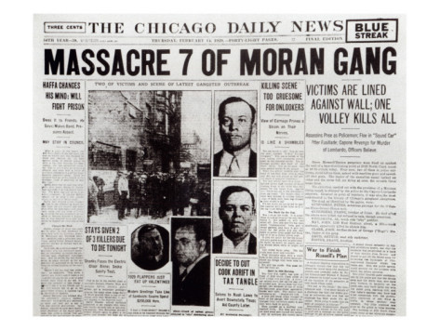

[The front page of The Chicago Daily News newspaper carrying the news of the St Valentine’s Day massacre]

Use Source A and your own knowledge to describe the St Valentine’s Day Massacre.
[6]
--------------------------------------------------------------------------------------------------------------------------------------------------------------------------------------------------------------------------------------------------------------------------------------------------------------------------------------------------------------------------------------------------------------------------------------------------------------------------------------------------------------------------------------------------------------------------------------------------------------------------------------------------------------------------------------------------------------------------------------------------------------------------------------------------------------------------------------------------------------------------------------------------------------------------------------------------------------------------------------------------------------------------------------------------------------------------------------------------------------
Turn over.
--------------------------------------------------------------------------------------------------------------------------------------------------------------------------------------------------------------------------------------------------------------------------------------------------------------------------------------------------------------------------------------------------------------------------------------------------------------------------------------------------------------------------------------------------------------------------------------------------------------------------------------------------------------------------------------------------------------------------------------------------------------------------------------------------------------------------------------------------------------------------------------------------------------------------------------------------------------------------------------------------------------------------------------------------------------------------------------------------------------------------------------------------------------------------------------------------------------------------------------------------------------------------------------------------------------------------------------------------------------------------------------------
Examiner only

QUESTION 2
Examiner only
This question is about immigration
Describe the Open Door Policy. [8]
----------------------------------------------------------------------------------------------------------------------------------------------------------------------------------------------------------------------------------------------------------------------------------------------------------------------------------------------------------------------------------------------------------------------------------------------------------------------------------------------------------------------------------------------------------------------------------------------------------------------------------------------------------------------------------------------------------------------------------------------------------------------------------------------------------------------------------------------------------------------------------------------------------------------------------------------------------------------------------------------------------------------------------------------------------------------------------------------------------------------------------------------------------------------------------------------------------------------------------------------------------------------------------------------------------------------------------------------------------------------------------------------------------------------------------------------------------------------------------------------------------------------------------------------------------------------------------------------------------------------------------------------------------------------------------------------------------------------------------------------------------------------------------------------------------------------------------------------------------------------------------------------------------------------------------------------------------------------------------------------------------------------------------------------------------------------------------------------------------------------------------------------------------------------------------------------------------------------------------------------------------------------------------------------------------------------------------------------------------------------------------------------------------------------------------------------------------------------------------------------------------------------------------------------------------------------------------------------------------------------------------------------------------------------------------------------------------------------------------------------------------------------------------------

QUESTION 3
This question is about Religion and Race
Study the source below and then answer the question which follows.
Source B
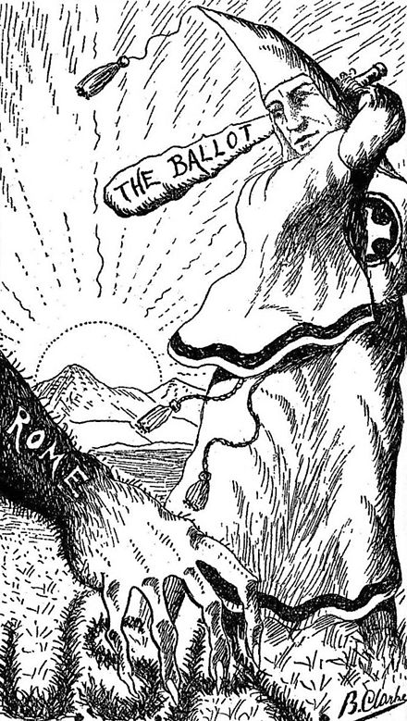

[A Cartoon published in a magazine during the presidential campaign of 1928. The democrat candidate Alfred Smith was Roman Catholic.]

What was the purpose of Source B? [8]

[Use details from Source B and your own knowledge and understanding of the historical context to answer the question.]

------------------------------------------------------------------------------------------------------------------------------------------------------------------------------------------------------------------------------------------------------------------------------------------------------------------------------------------------------------------------------------------------------------------------------------------------------------------------------------------------------------------------------------------------------------------------------------------------------------------------------------------------------------------------------------------------------------------------------------------------------------------------------------------------------------------------------------------------------------------------------------------------------------------------------------------------------------------------------------------------------------------------------------------------------------------------------------------------------------------------------------------------------------------------------------------------------------------------------------------------------------------------------------------------------------------------------------------------------------------------------------------------------------------------------------------------------------------------------------------------------------------------------------------------------------------------------------------------------------------------------------------------------------------------------------------------------------------------------------------------------------------------------------------------------------------------------------------------------------------------------------------------------------------------------------------------------------------------------------------------------------------------------------------------------------------------------------------------------------------------------------------------------------------------------------------------------------------------------------------------------------------------------------------------------------------------------------------------------------------------------------------------------------------------------------------------------------------------------------------------------------------------------------------------------------------------------------------------------------------------------------------------------------------------------------------------------------------------------------------------------------------------------------------------------------------------------------------------------------------------------------------------------------------------------------------------------------------------------------------------------------------------------------------------------------------------------------------------------------------------------------------------------------------------------------------------------------------------------------------------------------------------------------------------------------------------------------------------
QUESTION 4
This question is about the role of women.
Study the sources below and then answer the question that follows.
Source
Jane’s a flapper. Let us take a look at the young person as she strolls across the lawn of her parents’ suburban home, having just put the car away after driving sixty miles in two hours. She is, for one thing a pretty girl. Beauty is the fashion in 1925. She is frankly heavily made up with poisonously scarlet lips and richly ringed eyes. As for her clothes, Jane isn’t wearing much this summer. Her dress is brief. It is cut low. The skirt comes just below the knees. The bra has been abandoned since 1924.

[An article called ‘Flapper Jane’ published in September 1925 in ‘The New Republic’ a liberal magazine which commented on politics and the arts.]
.
Source D
Think of the modern young American girls of this great country. Do they ever think? Do they ever ask whence they have come? It would seem not. Their aim appears to be to attract men and to secure money. What can a man with a mind find to hold him in one of these lovely, brainless, cigarette-smoking creatures of undisciplined sex whom he meets continually?

[An English Journalist, living in the USA, writing about flappers in the USA in 1921 for an American newspaper]

Which of the sources is more useful to an historian studying the Flapper lifestyles in the 1920s?
[12]
[You should refer to both sources in your answer and use your knowledge and understanding of the historical context.]

------------------------------------------------------------------------------------------------------------------------------------------------------------------------------------------------------------------------------------------------------------------------------------------------------------------------------------------------------------------------------------------------------------------------------------------------------------------------------------------------------------------------------------------------------------------------------------------------------------------------------------------------------------------------------------------------------------------------------------------------------------------------------------------------------------------------------------------------------------------------------------------------------------------------------------------------------------------------------------------------------------------------------------------------------------------------------------------------------------------------------------------------------------------------------------------------------------------------------------------------------------------------------------------------------------------------------------------------------------------------------------------------------------------------------------------------------------------------------------------------------------------------------------------------------------------------------------------------------------------------------------------------------------------------------------------------------------------------------------------------------------------------------------------------------------------------------------------------------------------------------------------------------------------------------------------------------------------------------------------------------------------------------------------------------------------------------------------------------------------------------------------------------------------------------------------------------------------------------------------------------------------------------------------------------------------------------------------------------------------------------------------------------------------------------------------------------------------------------------------------------------------------------------------------------------------------------------------------------------------------------------------------------------------------------------------------------------------------------------------------------------------------------------------------------------------------------------------------------------------------------------------------------------------------------------------------------------------------------------------------------------------------------------------------------------------------------------------------------------------------------------------------------------------------------------------------------------------------------------------------------------------------------------------------------------------------------------------------

--------------------------------------------------------------------------------------------------------------------------------------------------------------------------------------------------------------------------------------------------------------------------------------------------------------------------------------------------------------------------------------------------------------------------------------------------------------------------------------------------------------------------------------------------------------------------------------------------------------------------------------------------------------------------------------------------------------------------------------------------------------------------------------------------------------------------------------------------------------------------------------------------------------------------------------------------------------------------------------------------------------------------------------------------------------------------------------------------------------------------------------------------------------------------------------------------------------------------------------------------------------------------------------------------------------------------------------------------------------------------------------------

QUESTION 5
This question is about the economic boom experienced in 1920s America.

Was the impact of the First World War the main reason for America’s economic boom in the 1920s? [16]
Use your own knowledge and understanding of the issue to support your answer. Marks for spelling, punctuation and the accurate use of grammar and specialist language are allocated to this question. [3]

------------------------------------------------------------------------------------------------------------------------------------------------------------------------------------------------------------------------------------------------------------------------------------------------------------------------------------------------------------------------------------------------------------------------------------------------------------------------------------------------------------------------------------------------------------------------------------------------------------------------------------------------------------------------------------------------------------------------------------------------------------------------------------------------------------------------------------------------------------------------------------------------------------------------------------------------------------------------------------------------------------------------------------------------------------------------------------------------------------------------------------------------------------------------------------------------------------------------------------------------------------------------------------------------------------------------------------------------------------------------------------------------------------------------------------------------------------------------------------------------------------------------------------------------------------------------------------------------------------------------------------------------------------------------------------------------------------------------------------------------------------------------------------------------------------------------------------------------------------------------------------------------------------------------------------------------------------------------------------------------------------------------------------------------------------------------------------------------------------------------------------------------------------------------------------------------------------------------------------------------------------------------------------------------------------------------------------------------------------------------------------------------------------------------------------------------------------------------------------------------------------------------------------------------------------------------------------------------------------------------------------------------------------------------------------------------------------------------------------------------------------------------------------------------------------------------------------------------------------------------------------------------------------------------------------------------------------------------------------------------------------------------------------------------------------------------------------------------------------------------------------------------------------------------------------------------------------------------------------------------------------------------------------------------------------------------------------------------------------------------------------------------------------------------------------------------------------------------------------------------------------------------------------------------------------------------------------------------------------------------------------------------------------------------------------------------------------------------------------------------------------------------------------------------------------------------------------------------------------------------------------------------------------------------------------------------------------------------------------------------------------------------------------------------------------------------------------------------------------------------------------------------------------------------------------------------------------------------------------------------------------------------------------------------------------------------------------------------------------------------------------------------------------------------------------------------------------------------------------------------------------------------------------------------------------------------------------------------------------------------------------------------------------------------------------------------------------------------------------------------------------------------------------------------------------------------------------------------------------------------------------------------------------------------------------------------------------------------------------------------------------------------------------------------------------------------------------------------------------------------------------------------------------------------------------------------------------------------------------------------------------------------------------------------------------------------------------------------------------------------------------------------------------------------------------------------------------------------------------------------------------------------------------------------------------------------------------------------------------------------------------------------------------------------------------------------------------------------------------------------------------------------------------------------------------------------------------------------------------------------------------------------------------------------------------------------------------------------------------------------------------------------------------------------------------------------------------------------------------------------------------------------------------------------------------------------------------------------------------------------------------------------------------------------------------------------------------------------------------------------------------------------------------------------------------------------------------------------------------------------------------------------------------------------------------------------------------------------------------------------------------------------------------------------------------------------

