QUESTION 1
Examiner only
This question is about the Impact of the First World War
Study the source below and then answer the question which follows.
Source A
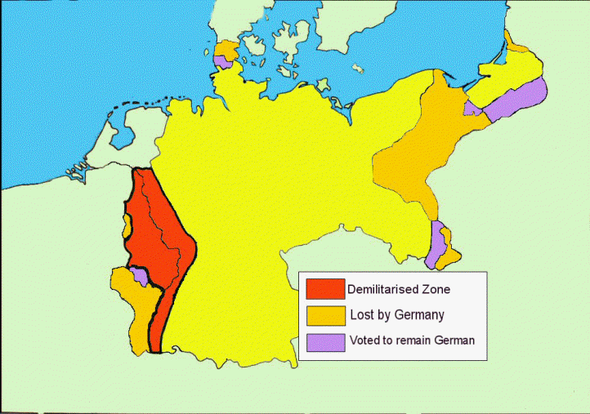

[Map showing the territorial terms of the Treaty of Versailles]
Use Source A and your own knowledge to describe the territorial clauses of the Treaty of Versailles [6]
Examiner only

------------------------------------------------------------------------------------------------------------------------------------------------------------------------------------------------------------------------------------------------------------------------------------------------------------------------------------------------------------------------------------------------------------------------------------------------------------------------------------------------------------------------------------------------------------------------------------------------------------------------------------------------------------------------------------------------------------------------------------------------------------------------------------------------------------------------------------------------------------------------------------------------------------------------------------------------------------------------------------------------------------------------------------------------------------------------------------------------------------------------------------------------------------------------------------------------------------------------------------------------------------------------------------------------------------------------------------------------------------------------------------------------------------------------------------------------------------------------------------------------------------------------------------------------------------------------------------------------------------------------------------------------------------------------------------------------------------------------------------------------------------------------------------------------------------------------------------------------------------------------------------------------------------------------------------------------------------------------------------------------------------------------------------------------------------------------------------------------------------------------------------------------------------------------------------------------------------------------------------------------------------------------------------------------------------------------------------------------------------------------------------------------------------------------------------------------------------------------------------------------------------
Turn over.

QUESTION 2
Examiner only
This question is about challenges faced by the Weimar Republic
Describe what happened during the Spartacist uprising in January 1919 [8]
--------------------------------------------------------------------------------------------------------------------------------------------------------------------------------------------------------------------------------------------------------------------------------------------------------------------------------------------------------------------------------------------------------------------------------------------------------------------------------------------------------------------------------------------------------------------------------------------------------------------------------------------------------------------------------------------------------------------------------------------------------------------------------------------------------------------------------------------------------------------------------------------------------------------------------------------------------------------------------------------------------------------------------------------------------------------------------------------------------------------------------------------------------------------------------------------------------------------------------------------------------------------------------------------------------------------------------------------------------------------------------------------------------------------------------------------------------------------------------------------------------------------------------------------------------------------------------------------------------------------------------------------------------------------------------------------------------------------------------------------------------------------------------------------------------------------------------------------------------------------------------------------------------------------------------------------------------------------------------------------------------------------------------------------------------------------------------------------------------------------------------------------------------------------------------------------------------------------------------------------------------------------------------------------------------------------------------------------------------------------------------------------------------------------------------------------------------------------------------------------------------------------------------------------------------------------------------------------------------------------------------------------------------------------------------------------------------------------------------------------------------------------------------------------------------------------------------------------------------------------------------------------------------------------------------------------------------------------------------------------------------------------------------------------------------------------

QUESTION 3
This question is about the invasion of the Ruhr 1923
Study the source below and then answer the question which follows.
Source B
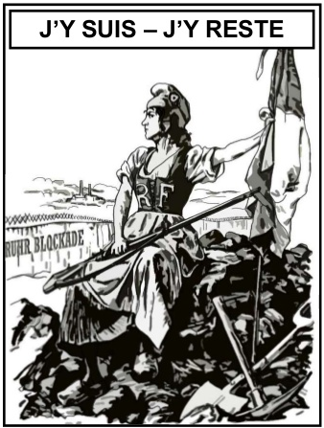

[A British cartoon from Punch 1923, the writing translates ‘Here I am – Here I stay’]

What was the purpose of Source B? [8]

[Use details from Source B and your own knowledge and understanding of the historical context to answer the question.]

------------------------------------------------------------------------------------------------------------------------------------------------------------------------------------------------------------------------------------------------------------------------------------------------------------------------------------------------------------------------------------------------------------------------------------------------------------------------------------------------------------------------------------------------------------------------------------------------------------------------------------------------------------------------------------------------------------------------------------------------------------------------------------------------------------------------------------------------------------------------------------------------------------------------------------------------------------------------------------------------------------------------------------------------------------------------------------------------------------------------------------------------------------------------------------------------------------------------------------------------------------------------------------------------------------------------------------------------------------------------------------------------------------------------------------------------------------------------------------------------------------------------------------------------------------------------------------------------------------------------------------------------------------------------------------------------------------------------------------------------------------------------------------------------------------------------------------------------------------------------------------------------------------------------------------------------------------------------------------------------------------------------------------------------------------------------------------------------------------------------------------------------------------------------------------------------------------------------------------------------------------------------------------------------------------------------------------------------------------------------------------------------------------------------------------------------------------------------------------------------------------------------------------------------------------------------------------------------------------------------------------------------------------------------------------------------------------------------------------------------------------------------------------------------------------------------------------------------------------------------------------------------------------------------------------------------------------------------------------------------------------------------------------------------------------------------------------------------------------------------------------------------------------------------------------------------------------------------------------------------------------------------------------------------------------------------------------------------

QUESTION 4
This question is about the events in the Ruhr 1923.
Study the sources below and then answer the question that follows.
Source C
By January 1923 the French had lost patience with the Germans. French and Belgium troops marched into the Ruhr to take the goods they needed in compensation for Germany failing to pay reparations. The German government called for a policy of ‘passive resistance’ and payed workers by printing more money. The caused inflation to rise and by April 1923 the government was spending seven times more that it was receiving in revenue. The result was hyperinflation, the value of the mark fell rapidly and became worthless.

[Historians Greg Lacey and Keith Shephard, writing in a history GCSE textbook, Germany 1918-1945 (1997)]
Source D
I vividly remember pay days at that time. I used to have to accompany the manager to the bank in an open six seater Benz which we filled to the brim with bundles and bundles of million mark notes. We drove back through the narrow streets quite unmolested. And when they got their wages, the workmen did not even bother to count the number of notes in each bundle.

[A question from a Nazi math’s textbook, 1933]

[A worker in a transport firm interviewed for a book made up of personal memories, Life during the Weimar (1968)]

Which of the sources is more useful to an historian studying the Weimar economy and the events of 1923?
[12]
[You should refer to both sources in your answer and use your knowledge and understanding of the historical context.]
--------------------------------------------------------------------------------------------------------------------------------------------------------------------------------------------------------------------------------------------------------------------------------------------------------------------------------------------------------------------------------------------------------------------------------------------------------------------------------------------------------------------------------------------------------------------------------------------------------------------------------------------------------------------------------------------------------------------------------------------------------------------------------------------------------------------------------------------------------------------------------------------------------------------------------------------------------------------------------------------------------------------------------------------------------------------------------------------------------------------------------------------------------------------------------------------------------------------------------------------------------------------------------------------------------------------------------------------------------------------------------------------------------------------------------------------------------------------------------------------------------------------------------------------------------------------------------------------------------------------------------------------------------------------------------------------------------------------------------------------------------------------------------------------------------------------------------------------------------------------------------------------------------------------------------------------------------------------------------------------------------------------------------------------------------------------------------------------------------------------------------------------------------------------------------------------------------------------------------------------------------------------------------------------------------------------------------------------------------------------------------------------------------------------------------------------------------------------------------------------------------------------------------------------------------------------------------------------------------------------------------------------------------------------------------------------------------------------------------------------------------------------------------------------------------------------------------------------------------------------------------------------------------------------------------------------------------------------------------------------------------------------------------------------------------------------------------------------------------------------------------------------------------------------------------------------------------------------------------------------------------------------------------------------------------------------------------------------------------------------------------------------------------------------------------------------------------------------------------------------------------------------------------------------------------------------------------------------------------------------------------------------------------------------------------------------------------------------------------------------------------------------------------------------------------------------------------------------------------------------------------------------------------------------------------------------------------------------------------------------------------------------------------------------------------------------------------------------------------------------------------------------------------------------------------------------------------------------------------------------------------------------------------------------------------------------------------------------------------------------------------------------------------------------------------------------------------------------------------------------------------------------------------------------------------------------------------------------------------------------------------------------------------------------------------------------------------------------------------------------

QUESTION 5
This question is about life in Nazi Germany.
Was the Munich Beer Hall Putsch a great success for Hitler and the Nazis? [16]
Use your own knowledge and understanding of the issue to support your answer. Marks for spelling, punctuation and the accurate use of grammar and specialist language are allocated to this question. [3]

------------------------------------------------------------------------------------------------------------------------------------------------------------------------------------------------------------------------------------------------------------------------------------------------------------------------------------------------------------------------------------------------------------------------------------------------------------------------------------------------------------------------------------------------------------------------------------------------------------------------------------------------------------------------------------------------------------------------------------------------------------------------------------------------------------------------------------------------------------------------------------------------------------------------------------------------------------------------------------------------------------------------------------------------------------------------------------------------------------------------------------------------------------------------------------------------------------------------------------------------------------------------------------------------------------------------------------------------------------------------------------------------------------------------------------------------------------------------------------------------------------------------------------------------------------------------------------------------------------------------------------------------------------------------------------------------------------------------------------------------------------------------------------------------------------------------------------------------------------------------------------------------------------------------------------------------------------------------------------------------------------------------------------------------------------------------------------------------------------------------------------------------------------------------------------------------------------------------------------------------------------------------------------------------------------------------------------------------------------------------------------------------------------------------------------------------------------------------------------------------------------------------------------------------------------------------------------------------------------------------------------------------------------------------------------------------------------------------------------------------------------------------------------------------------------------------------------------------------------------------------------------------------------------------------------------------------------------------------------------------------------------------------------------------------------------------------------------------------------------------------------------------------------------------------------------------------------------------------------------------------------------------------------------------------------------------------------------------------------------------------------------------------------------------------------------------------------------------------------------------------------------------------------------------------------------------------------------------------------------------------------------------------------------------------------------------------------------------------------------------------------------------------------------------------------------------------------------------------------------------------------------------------------------------------------------------------------------------------------------------------------------------------------------------------------------------------------------------------------------------------------------------------------------------------------------------------------------------------------------------------------------------------------------------------------------------------------------------------------------------------------------------------------------------------------------------------------------------------------------------------------------------------------------------------------------------------------------------------------------------------------------------------------------------------------------------------------------------------------------------------------------------------------------------------------------------------------------------------------------------------------------------------------------------------------------------------------------------------------------------------------------------------------------------------------------------------------------------------------------------------------------------------------------------------------------------------------------------------------------------------------------------------------------------------------------------------------------------------------------------------------------------------------------------------------------------------------------------------------------------------------------------------------------------------------------------------------------------------------------------------------------------------------------------------------------------------------------------------------------------------------------------------------------------------------------------------------------------------------------------------------------------------------------------------------------------------------------------------------------------------------------------------------------------------------------------------------------------------------------------------------------------------------------------------------------------------------------------------------------------------------------------------------------------------------------------------------------------------------------------------------------------------------------------------------------------------------------------------------------------------------------------------------------------------------------------------------------------------------------------------------------------------------------------------------------------

