Individual Project – Initial Project Ideas
Enter here your career aspirations and /or interest idea.
Make a spider diagram on possible ideas on what you could do that is related to your theme.
FRONT COVER - Add your title and any images that represent what your project is about (example below).

To create a guide on how to build a wall for a garden
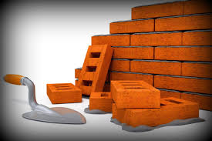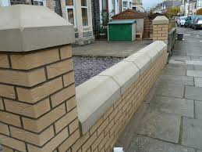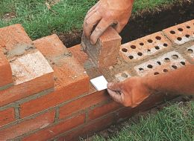

Contents
- Introduction
- Aims and Objectives
- Rational for your Research Methods
- Development Record
  - Secondary Data Analysis
  - Primary Data Analysis
- Conclusion
- Evaluation
- Bibliography
- Appendix

Introduction

Aims and Objectives

Aim 1 -
Objectives for aim 1

Aim 2 -
Objectives for aim 2

Aim 3 -
Objectives for aim 1

Rationale for your Research Methods

Development Record: Secondary Research

Development Record- Go to your development plan to start your artefact

Primary Research
Analyse what you have found out from your research here.

Development of My Product
Add here any pictures / screen shots of you designing your product.

Final Product
Add photos of your final product here.
Annotate what you have done to meet your aims and objectives.

Conclusion

Evaluation

Bibliography
Source | Details of Source | What information did you use this information for? | How was this source successful?
e.g. Internet | https://targetjobs.co.uk/careers-advice/choosing-an-employer/320357-which-graduate-career-offers-the-best-pay | This website gave me information on the top paying graduate jobs | This website helped me understand the different starting wages for different types of graduation jobs

Appendix

