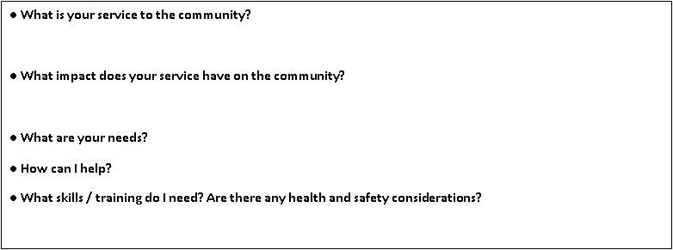

**● What is your service to the community?**

**● What impact does your service have on the community?**

**● What are your needs?**

**● How can I help?**

**● What skills / training do I need? Are there any health and safety considerations?**

**TASK**: APPROACH AT LEAST 2 DIFFERENT AGENCIES TO ASK THESE QUESTIONS AND FILL IN THEIR RESPONSES.

**My community needs**