How to present your data as a chart.

- Open an Excel spreadsheet.

- Type in multiple choice answers into column A, and data into column B

- Highlight only column A and B (if you highlight more than these two columns the Chart Wizard will not work.
- Click on Chart Wizard button.

- Chart Wizard Step 1 of 4. Select the chart you wish to use. Click Next.
- Chart Wizard Step 2 of 4. Do not do anything here, just proceed to step 3 by clicking Next.

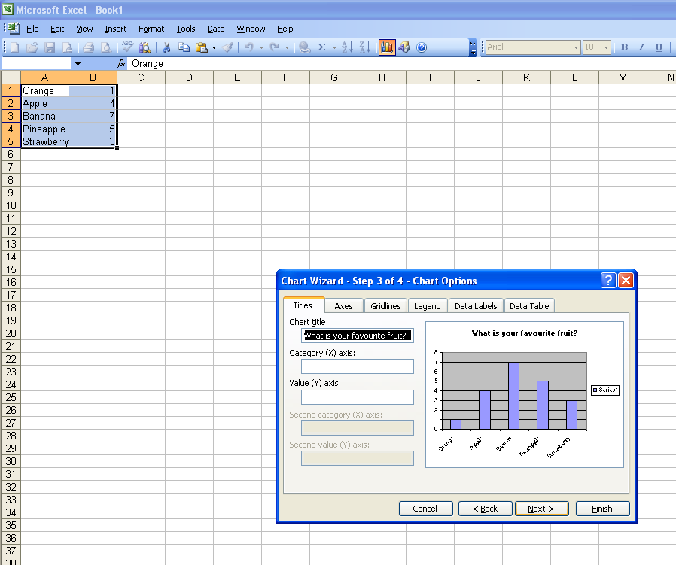
- Chart Wizard Step 3 of 4. Type in your title. Click Next
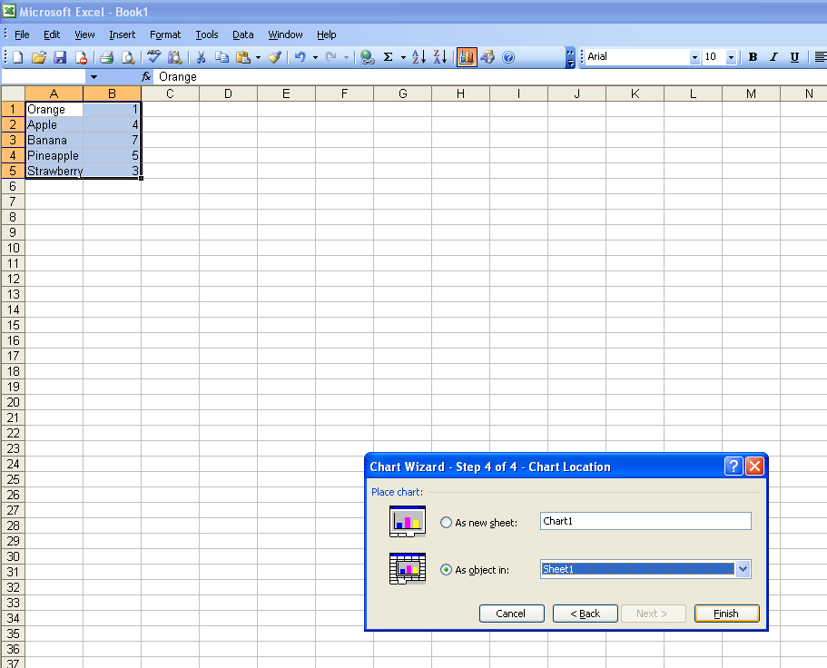
- Chart Wizard Step 4 of 4. Do not do anything here; just proceed to finish by clicking Finish.
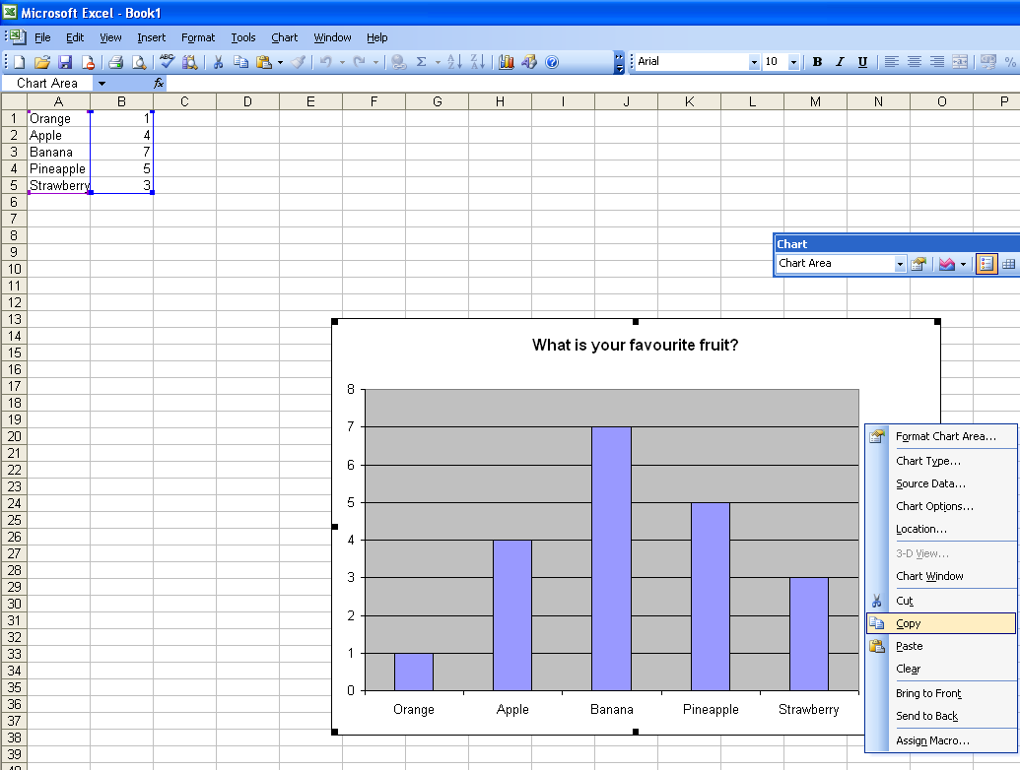
- Hey presto!! Your chart will now appear

Right click so you get some options and then please copy and paste into a word document and layout 6 to an A4 page.
- Please SAVE your word document

