Opera House wins top status
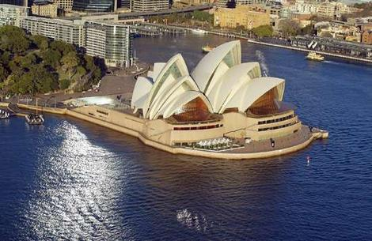
World class listing ... for the Opera House.
Photo: Bob Pearce
June 28, 2007
The Sydney Opera House has been declared a World Heritage site and a masterpiece of 20th-century architecture.
It takes its place alongside the Taj Mahal, the Acropolis and the Great Pyramids as a cultural site having outstanding universal value.
The decision was made in Christchurch, New Zealand, at a meeting of the United Nations Education, Scientific and Cultural Organisation's World Heritage Committee.
The Opera House, designed by Joern Utzon and officially opened in October 1973, is the youngest building to be included on the World Heritage list and only the second by a living architect.
The committee has described the Opera House as of unparalleled design and construction.
"It is a daring and visionary experiment that has had an enduring influence on the emergent architecture of the late 20th-century," according to the committee.
"The building is a great artistic monument and an icon."
Mr Utzon said the listing gave the building a completely new value.
"I heard several times after we finished the Opera House that it is the greatest asset for the city. That was what we were aiming at - all the people who worked with me and all the people who asked for the building,'' Mr Utzon said. "For an architect and for all the poeple who have worked on it, (this recognition gives us) the real feeling of what we are here for."
The Minister for the Environment and Water Resources, Malcolm Turnbull, congratulated Mr Utzon, saying the genius of his design demanded outstanding engineering feats and new technologies.
The building, he said, was one of only 15 or so 20th century buildings to gain a world heritage listing and one of only the second in Australia, after Melbourne's Royal Exhibition Building in Carlton Gardens.
"It sets this building up right where it belongs at the very summit of world architectural achievement,'' he said.
New South Wales Planning Minister Frank Sartor said the Opera House attracted more than 4 million visitors a year and the world heritage listing would boost its appeal as a tourist attraction.
The listing has been a long-held goal for the Opera House, which attempted an inclusion in 1981.
The nine-day UNESCO meeting is considering the inclusion of 45 natural and cultural sites, including India's Red Fort in Delhi.
The listing will mean the creation of a 2.5-kilometre buffer zone around the Opera House to protect views to and from the site. Any development within the zone will be subject to additional scrutiny.
If the World Heritage values of the site are breached, the site can be placed on an endangered list and ultimately removed from the list.
The listing is expected to increase visitors to the Opera House.
An estimated 4.5 million people visit the Opera House annually of which 1.5 million attend a show.
The listing comes as the Opera House is poised to become the venue for the APEC conference in September when world leaders, including US President George Bush, will be in Sydney.
It also comes as the Opera House is considering a major renovation program to address long-standing sound and other mechanical problems. This work is not expected to be affected by the listing.
- with David Braithwaite

