BRAINSTORMING SOLUTIONS
Problem:

SOLUTIONS
Replacing/Inventing  a substitute/Making it unnescessary | Imroving/Changing/  Adapting | Other ideas for solution

SELF ADVERTISEMENT

WHAT IS SHE THINKING 1
You have two minutes to study the picture of the pretty young lady turning her face away and write a sentence about what she is thinking.

The pretty young lady in the fur coat is thinking ________________
_________________________________________________________
_________________________________________________________
_________________________________________________________
_________________________________________________________

WHAT IS SHE THINKING 2
You have two minutes to study the picture of the ugly old hag with no teeth and write a sentence about what she is thinking.

The old woman in the black shawl is thinking ________________
_________________________________________________________
_________________________________________________________
_________________________________________________________
_________________________________________________________

FINDING YOUR OWN IDEAS
- Divide up the large sheet of paper your group has been given into columns as follows:
Making Things | Buying and selling | Giving a Service | Group Choice

- Choose five things from the list that you can do fairly well (or could learn) and put them in the appropriate column. Add some ideas of your own. Try to find about ten ideas for each column.

Housework Cooking
Dancing Muscle power
Photography Woodworking
Camping Metal working
Driving Computing
Building things Painting/Drawing
Fishing Computer design
Designing Making models
Jewellery Looking after children
Knitting Sewing
Talking to people Gardening
Word processing Fixing engines
Selling Painting and Decorating
Office work Mechanical things
Animals Making clothes
Making furniture Growing things
Beauty care Sport
Outdoor pursuits Entertainment
Web Design Computer games
App design Films

WAYS TO FIND IDEAS
Copying somebody else’s successful idea
Combining two or more ideas in a new way
Solving problems for people
Finding out what the ‘competition’ is bad at
Developing your hobby
Building on your skills
Turning waste material into something useful
Bringing ideas home from your holidays
Brainstorming in a group
Talking and listening to people
Making lists and playing around with them
Looking for ‘gaps’ in the market
Finding new ways to do things
Improving a product or a service
Daydreaming and fantasising
Looking at what things DO rather than what they ARE
Listening when people say ‘if only...’
Being always on the lookout for opportunities
Thinking in new ways

CHECKING OUT IDEAS
Unless your idea works, it is not much use yet.
Use this checklist to check out a few of the possible business ideas that you have generated. You can use it again later to check out your own personal ideas for your ‘project’. Some of the questions might not concern your idea and other important questions might be missing – insert these yourself.
Aim to end up with positive answers. You need to check out answers before you start, otherwise you may be taking too much of a risk.
Questions | Yes | Not Sure | No | Need more information
!. Does it work and will it keep on working?
2.Can you do it all yourself or with help?
3. Will sufficient people buy it?
4. Is it ‘better’ than the competition?
5. Do other people think it is worthwhile?
6. Is location important?

7. Can you sell at a price worthwhile to you?
8. Can you ‘hire’ or ‘buy’ any specialist skills needed?
9. Is it legal?

10. Is it safe?

11.

12.

SWOT ANALYSIS
Make a SWOT analysis of your new enterprise

STRENGTHS | WEAKNESSES
OPPORTUNITIES | THREATS

EXAMPLE QUESTIONNAIRE
Hello, I wonder if you would mind helping me?
I am a member of a small business which is planning to sell a product (or service) in the area but before we do, we are checking out people’s reactions. (You could show product or service)

- How often do you buy it? (If not bought, ask ‘Why not?’)

- Where do you buy it?

- Why do you buy it?

- What do you pay for it?

- What do you like about it?

- What could be improved about it?

- How does ours compare with others?

- Would you be willing to buy ours?

- What do you like about ours?

- What could be improved in ours?

- What is a good price for ours?

- Any other comments or suggestions?

Male/Female
Age group: Under 16 16- 25 26-35 35 plus
Occupation
Thank you for your time and help

USING EXCEL TO CREATE A CHART OR GRAPH
Step 1 - Launch Excel - If Excel is already open on your workstation open a new Excel workbook, There are three ways to do that.
1. Go to the Standard toolbar. Click on the New Workbook button.
2. Go to the File menu. Select New. 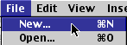
3. Use a keyboard combination: on a Macintosh use Command + N and on a Windows computer use Ctrl + N
Step 2 - Enter the data to be graphed. For the purpose of this lesson you will use data from a Favorite Fruit Survey. Enter it as you see below:
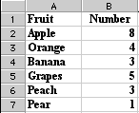
Step 3 - Highlight data to be graphed. Do not include the row with heading titles, only the names of fruit and the numbers. If your worksheet looks like the one above; put your cursor in call A2, click hold the mouse button down and drag to cell B7. Highlighted data should look like the image below:
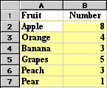
Note: Cell A2 is selected, the select color extends around the cell
Step 4 - Select the Chart Wizard. That is done by going to the Insert menu and selecting Chart. You can also click on the Chart Wizard button on the Standard toolbar.
Step 5 - From the Chart Wizard box that opens select Chart type. For this activity, I selected pie.
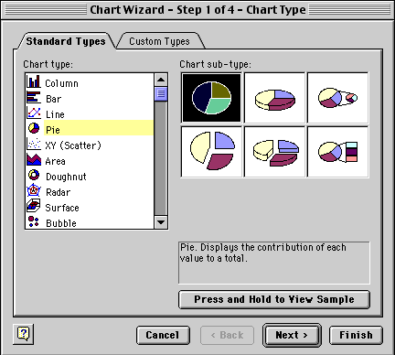
After you have selected the Chart type, click and hold your mouse pointer down on the Press and Hold... button to see what your data looks like in the chart type you selected. If you do not like the look, select another chart type. After you have selected the chart type you will have two options:
- Select Next and let Chart Wizard show you a series of options to make changes to your chart.
- Select Finish and Chart Wizard puts your completed chart on the spreadsheet. You can see the finished product below.
The second step taken by Chart Wizard is to verify the range of data being used for this chart. The Data range displayed below is read "all cells from A2 to B7."

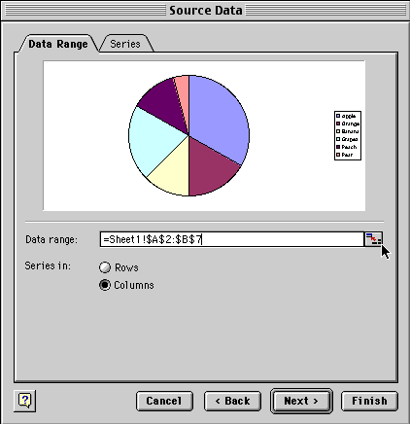
Notice where the cursor is located in the dialog box above. It is pointing to the small box at the end of the line where the Data range is displayed. If the data range should be changed, click on the box the cursor is pointing to.
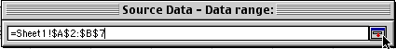
The dialog box shrinks allowing you to see your entire spreadsheet. You can edit the data range in this small window. When you are finished, click the same box at the end to restore the window.
Select Next to go to the dialog box below. This box allows you to add a title to the chart, make changes on the legend, or make changes on the data labels.
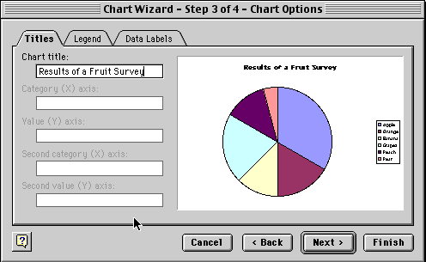
Select Next to move to the final dialog box which allows you to see the chart as a new sheet or place it on one of the sheets in your workbook.
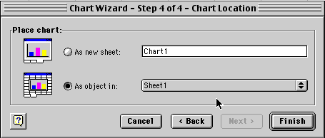
If you let the Chart Wizard finish your chart after the first dialog box, or work through each of the four steps, your chart will look something like the one below.
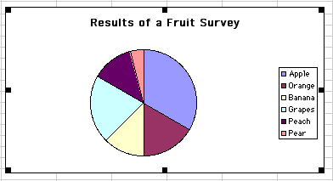

WHO ARE YOUR COMPETITORS
Who will you be competing with? _______________________________ ____________________________________________________________________________________________________________________________________________________________________________________________________________________________________

What do they do? ___________________________________________
____________________________________________________________________________________________________________________________________________________________________________________________________________________________________

What prices do they charge? __________________________________
____________________________________________________________________________________________________________________________________________________________________________________________________________________________________

Whaat are they good at? _____________________________________
____________________________________________________________________________________________________________________________________________________________________________________________________________________________________

What are they not so good at? _________________________________
____________________________________________________________________________________________________________________________________________________________________________________________________________________________________

Why is your product/service better than theirs? ____________________
____________________________________________________________________________________________________________________________________________________________________________________________________________________________________

Why do people buy from them? _______________________________
____________________________________________________________________________________________________________________________________________________________________________________________________________________________________
Do they give any ‘extras’? ____________________________________
____________________________________________________________________________________________________________________________________________________________________________________________________________________________________

What can you learn from them? ________________________________
____________________________________________________________________________________________________________________________________________________________________________________________________________________________________

WHO ARE YOUR CUSTOMERS
Make a list of all the different groups of customers who might be interested in bying your product/service. Why would they be interested?
____________________________________________________________________________________________________________________________________________________________________________________________________________________________________
____________________________________________________________________________________________________________________________________________________________________________________________________________________________________
____________________________________________________________________________________________________________________________________________________________________________________________________________________________________

Make a list of all the groups of customers your group has decided to concentrate on. Why have you decided on these?
____________________________________________________________________________________________________________________________________________________________________________________________________________________________________

Business Plan

Business plan contents:
Vision:  - The business idea  - Business aims  - What makes the business different  - Success factors | Marketing:  - Market research  - Promotion and advertising
Running the Business:

- Costs and receipts
Vision
1. Enterprise Idea:

Give a brief description of your enterprise idea

2. Business Aims:
What do you want to achieve?

3. What Makes the Business Different?

How is your product unique or different compared to the competition?

Vision
4. Success Factors:

Why do you believe your business will be successful?

Marketing
5. Market Research:

Who are your customers?

What do your customers want?

6. Promotion and Advertising:

How and where will you promote your business idea?

Running the Business
7.Costs:
At what price will you sell this product to the customer?

Ma’s Pies – Case Study (Segments and Mixes)
Ma’s Pies were well named. They were just like Ma used to make but ‘Ma’s Pies’ was a pie shop. It was run by a widow who needed to make a living anf only knew how to cook, wash, iron etc – having always been a housewife until her husband died. Ma made good pies and she always had a good trade. People used to go out of their wya to buy HER pies. For some people, however, she was too far away even though they preferred her pies.
She thought of opening up another shop in another part of town but could not afford it. But she did have a van. If the customers could not come to her, she would go to them.
She got a second-hand warming oven and fitted it in the van and started touring the town arriving at the same time every week so that people could depend on her. She had to do this after she closed the shop at 5.00 p.m. When she arrived in a street she would honk the horn on her van. Over the months she built up a regular tea-time trade for her pies with customers she would not otherwise have had.
Eventually she took on staff to serve in the shop and to do the van round while she concentrated on managing the whole operation. Because this allowed her more time, she began building up another segment of the pie market – bulk orders for pie suppers at Over 60’s Clubs,Church Halls etc. Sh offered a full delivery service and guaranteed quality.

Questions:
How can you segment Ma’s market? On what basis?
What marketing mix has she put together for each segment?

Ma’s Pies – Case Study – Teacher notes

(Segements identified on the basis of meal time and/or location)
 | Segment A  The Hot Lunch | Segment B  The Hot Tea | Segment C  The Hot Supper
CUTOMERS | Shoppers, workers, local families near the shop | People at home who did not live or work near the pie shop | Groups that have pie suppers in the town
TIME | 9 – 5 especially 12-2 p.m. | 5 – 7 p.m. | After 7 p.m.

The different offering to each segment is:
PRODUCT | Ma’s Pies.  Convenient  Value for money  A hot snack  Lunch | Ma’s Pies  A readymade hot tea.  Conveniently available and reliably delivered giving good value for money | Ma’s Pies  A reliable, reputable/con-venient bulk catering service giving good value hot suppers
PROMOTION | Reputation  Brand name  Loyalty  Shop Front | Blowing horn  Catch phrase  Visibility  Reputation  Reliability  Signs on van | Word of mouth  Reputation  Contacting the de-  cision makers  Promotional letters and quotations
PLACE | The shop  Passing trade | The customer’s front door.  Going out to the customer | The location of supper (or meeting with the decision maker beforehand to get the order)
PRICE | Value for money  Middle range  Cheaper if not heated | Value for money  More than if bought from the shop due to the extra service of van delivery | Quantity discounts but more expensive than inferior pies  Affordable catering

HOW TO PICK AND MIX
Using the illustration, pick and mix form the boxes items to consider in connection with your product/service. (You can pick more than one from each box or put new sugestions in the boxes)
Design and Production Team
Packaging Design
Shape Looks
Model Performance
Range Colour
Quality Size

Sales Team

Market Stall
Craft Fair
Boot Sale
Friends
Door to door
Shops
School
Community Centre
Youth Club
Internet
Advertising Team
Leaflets
Logo
Posters
Branding
Word of mouth
Internet
Local Radio
Newspapers
Magazines
App
Newsletters
Special Promotions

PRODUCT

MARKET
RESEARCH
PROMOTION PLACE

PRICE
Cheapness Free Gifts
Price of Cometitors
Special Offers Profit
Expensive Discounts

Production and Finance Team

MARKETING MIX
Put your information for each group of customers in the boxes

 | Product | Promotion | Place | Price
Customer
Group A

Customer
Group B

Customer
Group C

Customer
Group D

Customer
Group E

