Storing data effectively- Excel.
- Open an excel sheet up and enter the data as it appears below.
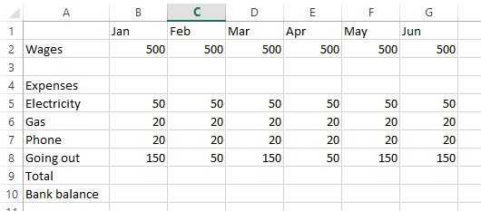
- You now need to enter a formula into the spreadsheet to add up the monthly outgoings and calculate the final bank balance.
  - To add up you need to ask the computer to do a SUM, to do this enter the formula below in cell B9:
=sum(B5:B8)
This is telling the computer it needs to add up all the figures in cells B5 B6 B7 and B8 and put it here.
  - To calculate the bank balance what calculation do you need to do? Write it below:

Once you have checked it with your teacher then enter it into cell B10

- Great stuff!! Now you want to `flood` the neighbouring cells with the formula, this is easy. Hoover on the right hand side bottom of cell B9, then drag across to cell G9

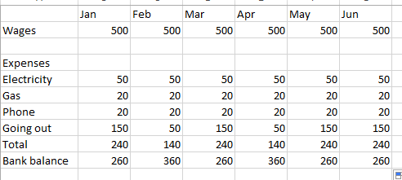
Completed sheet:

- Now to produce the charts. Select the data you want to use. Use the shift key to make multiple selections.

- Select INSERT and then the chart you want
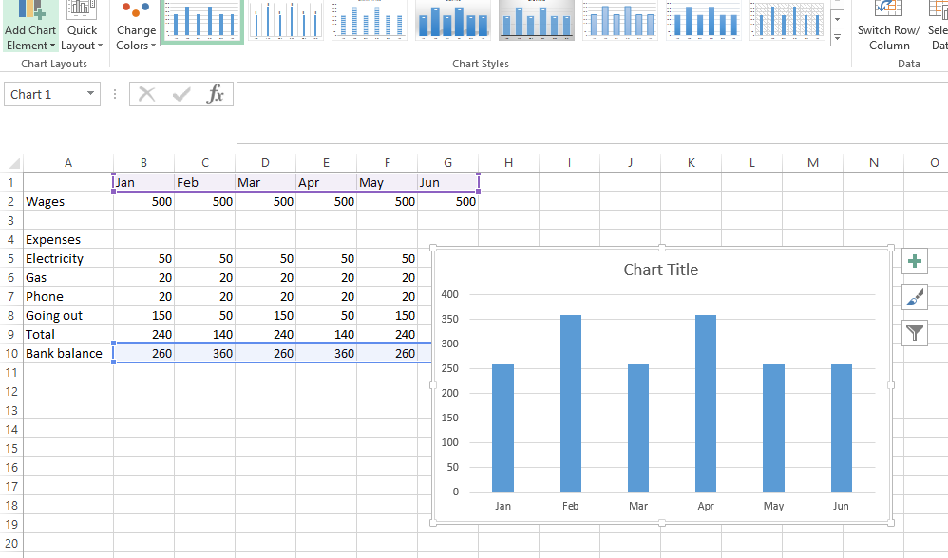

- Now add a title and you have competed the chart.
- To secure the data with a password on the file go to SAVE AS and then select tools and general options then enter the password.

