Observations in research.
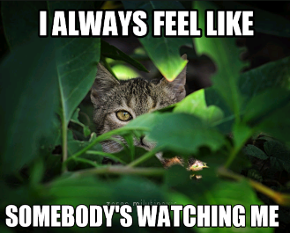
Learning Objectives
- To understand what an observation is
- To identify when an observation is appropriate
- To consider the ethical implications of an observation
What is an observation?
The process of watching or monitoring a situation or person over a period of time.
Have you ever been observed? In a lesson or in a sport? How did it make you feel?

What was the impact on what you did?

What is an observation and how would you undertake them? (Individual research or YouTube clips)
Observations come in 2 main forms naturalistic and participant.
Naturalistic observations take place when you observe a natural behavior in a natural setting. This is good because it is more valid and reliable however you can get observer bias if the person knows they are being watched. This is when a behavior is altered because the person knows they are being watched.
Participant observations is when the observer takes part in the activity, this means the observer plays a part in the observation and because of this they can sometimes direct behaviors the way they want, this could be an unconscious bias.
Structured observations are when there is a list of expected behaviors or outcomes expected and every time they are observed a record of this is made. This form of observation gives some quantitative data.
Advantages and disadvantages of observations:
Advantages | Disadvantages
Natural environment, not forced behaviours.  Low cost to set up.  Valid and reliable.  Can be applied to wider population in some cases | How do you get consent for people to take part?  If someone is told they are being observed then they may adapt their behaviour.  What one person sees another may miss- large scale observations you cant have eyes everywhere.  You may not observe the behaviour you wanted to observe.  Can be time consuming

Sampling in Observations
Event sampling
Researcher records an event every time it happens. For example, ticking a box every time somebody picks their nose. Although behaviours should not be missed as in time sampling, if too many observations happen at once it may be hard to record everything.
Time sampling
The researcher decides on a time such as every 10 seconds and then records what behaviour is occurring at that time. Time sampling may mean some behaviours will be missed and therefore the observation may not be representative.

