Observations in research.
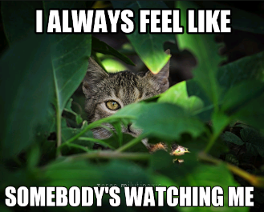
Learning Objectives
- To understand what an observation is
- To identify when an observation is appropriate
- To consider the ethical implications of an observation
What is an observation?
Have you ever been observed? In a lesson or in a sport? How did it make you feel?

What was the impact on what you did?

What is an observation and how would you undertake them? (Individual research or YouTube clips)

Advantages and disadvantages of observations:
Advantages | Disadvantages

Sampling in Observations
Event sampling

Time sampling

